Study of ICT Outsourcing and Offshoring
in Australia

April 2004

Whitehorse Strategic Group Ltd.



©Whitehorse Strategic Group Ltd.

ABN 17 006 784 407

Head Office
Level 3
45 William Street
Melbourne, Victoria 3000
Telephone: (61-3) 9614 8510
Facsimile: (61-3) 9614 8201

Online
Email: admin@whitehorsestrategic.com.au
Website: www.whitehorsestrategic.com.au

About Whitehorse Strategic Group
Whitehorse Strategic Group is an Australian owned management consulting practice founded in 1987 with a well established reputation in helping Industry and Government achieve success through strategies designed to maximise existing investments and capture efficiencies from new technologies. The Whitehorse Research Services Division produces the ‘Top 250’ ICT Industry Research Report, widely recognised as the leading creditable indicator of trends in the Australian ICT industry. Whitehorse principals specialise in the areas of ICT and Biotechnology Market Research, eGovernment policy and strategy, Business Process Management, and Economic and Community Development.
Table of Contents
1. Executive Summary 6
1.1 Difficult report to write 6
1.2 The Main Task 6
1.3 International confusion 6
1.4 “Headline driven” statistics 6
1.5 Need for reality check 7
1.6 Prediction 8
1.7 Economic effect 8
1.8 The economic offset – “Inshoring” 9
1.9 The devil’s advocate 10
1.9.1 Change, Skills, Cycle, Demography, Temporary trend 10
1.9.2 “Panacea” Outsourcing effect 11
1.10 Outsourcing Key Findings 13
2. Defining ICT Outsourcing 14
2.1 The Objective of the Study 14
2.2 Defining ICT Outsourcing 14
2.3 The Outsourcing “market” 15
3. Quantifying ICT Outsourcing 16
3.1 Introduction 16
3.2 Estimates of Global Market Size 16
3.2.1 Offshore quantification 18
4. Qualifying IT Outsourcing 20
4.1 Factors Affecting the Global Market 20
4.1.1 “Cycle Theory” 21
4.1.2 India –the leading provider of Offshore ICT services – Why? 23
4.1.3 Scale and Type of Work moved Offshore 24
4.1.4 Different models of ICT outsourcing 26
4.1.5 Composition of Offshored IT work 26
4.2 Factors driving Offshoring 28
4.2.1 Growth and change in Offshoring 28
5. The Australian IT Context 31
5.1 Introduction 31
5.2 ICT Employment in Australia 32
5.2.1 Offshoring Employment Composition 33
5.3 Australian Factors influencing trend towards Offshore Outsourcing 34
5.3.1 Government support of Outsourcing 34
5.3.2 Uniqueness of the Australian ICT marketplace. 36
6. Impact of Offshoring on ICT Employment Growth in Australia 37
6.1 Implications of IT Offshoring 37
6.1.1 Offshoring implications 38
6.2 Economic Impacts 40
6.2.1 Impact on tax base 41
6.2.2 The outsourcing employment bump 41
7. Likely Outsourcing and Offshoring market trends in Australia 43
7.1 Market slowdown 43
7.2 Our reasoning 43
7.2.1 Demand 43
7.2.2 Fashion 43
7.2.3 Cost-Benefit 43
7.3 Offshoring implication 44
7.3.1 The likely outcome 44
8. Options and Recommendations 45
8.1 ICT Industry Options 45
8.2 Australia as an Outsourcing destination 46
8.3 Options for Responding to Offshore ICT Outsourcing 47
Appendix One – Analyst Comments on the Global ICT Outsourcing Market 50
Appendix Two – Australian ICT Outsourcing Market Selected Examples 57
References 59

Abbreviations
ABS | Australian Bureau of Statistics
AIIA | Australian Information Industry Association
ANZSIC | Australian and New Zealand Standard Industry Classification
ATO | Australian Taxation Office
BPO | Business Process Outsourcing
CAGR | Compound Annual Growth Rate
DCITA | Department of Communications, Information Technology and the Arts
DEST | Department of Education, Science and Technology
DEWR | Department of Employment and Workplace Relations
DIMIA | Department of Immigration and Multicultural and Indigenous Affairs
EEA | European Economic Area
GCCA | Graduate Careers Council of Australia
GDP | Gross Domestic Product
ICT | Information and Communication Technology
IEEE | Institute of Electrical and Electronics Engineers
IT | Information Technology
ITAA | Information Technology Association of America
ITCRA | Information Technology Contract and Recruitment Association
ITT | Information Technology and Telecommunications
LFS | Labour Force Survey conducted by the ABS
LMT | Labour Market Testing
NASSCOM | Indian National Association of Software and Services Companies
NEC | Not Elsewhere Classified
OECD | Organisation for Economic Cooperation and Development
PG | Post Graduate
Top 250 | Whitehorse survey and statistical model of the ICT industry in Australia

1. Executive Summary
Whitehorse Strategic Group Ltd have conducted a number of studies into Outsourcing matters, and Whitehorse Directors Ian Dennis and David Goble are acknowledged Australian experts in this subject. Whitehorse were recently commissioned by the Australian Computer Society (ACS) to undertake a a study of Offshore ICT Outsourcing in Australia, and by the Victorian State Government to review the cost and other dynamics of “inshoring” or inwards ICT investment. These two studies have assisted us to develop this Report looking at both current and projected levels of outsourcing and offshoring and the implications of these findings for the Australian economy, Australian ICT workers, and the ICT industry.

1.1 Difficult report to write
A report of this nature is always difficult to write for the consultants. This is because it is about significant employment change, and in many cases, job losses. From the economic viewpoint, we consider ‘net’ job losses, rather than ‘gross’ losses. For the individuals concerned, however, every job that is lost is a personal tragedy. The economic netting effect, ie. that net employment change equals gross hiring less gross terminations, also means that a reported 10% net change in jobs may actually be 30% of the work-force facing restructure, change of ownership, or redundancy, and this can serve to mask the reality of human tragedy.
Net statistics can mask personal tragedy

1.2 The Main Task
Our main task, however, for this particular report, was to try to accurately quantify and qualify the problem, rather than to address the social implications of this issue. Accessing accurate information about outsourcing has been difficult. Outsourcing promotion and reporting has been characterised by hype and overstatement. Vendor's have often tended to overstate the value of the particular projects that they win, and in most cases, quote ‘gross’ sale values over multiple years that sometimes include assumptions concerning either escalation or inclusion of contractual items.
These ‘gross’ sale values also often include the value of capital equipment and other significant non-information technology components.

The reported employment implications of these projects tend to concentrate on the overall job reductions made by the client, but often do not accurately indicate how many of those jobs are retained by the vendor, or are replaced by the vendor engaging new staff, or by extending the utilisation of existing staff.

1.3 International confusion
We believe that the international position on outsourcing is confused, just as it is in Australia. Within the report, we have included an analysis of global forecasts emanating from many of the major analysts drawn from not only the outsourcing revenue predicted for the year concerned, but also the year in which the prediction was made. From this it can be seen that analysts who are frequently quoted, and whose predictions are used for many of the forward projections reported in newspapers, have, within the space of one or two years, often completely revised their original forecasts.
Market overhyped, overstated, confusion often driven by ‘market analysts’ and press

We can also see that the variation between the high and low predictions in any particular year can be massive. Another accuracy concern is that, almost without exception, analysts have tended to use potentially misleading straight-line CAGR projections for future years.

1.4 “Headline driven” statistics
The impact of outsourcing and offshoring on net employment is often overstated by the media, in which the gross displacement of employment is often reported as if it were a net effect.

As an example of this, a recent headline in Australian Computerworld stated:
“Vodafone sheds 100 staff under outsourcing program”.

The detail, lower in the article, indicated that 107 staff had been impacted by the outsource, but that 100 of them had been employed by one of the five outsourcing vendors, a net reduction of 7 staff rather than the 100 indicated in the headline.

Another, reasonably common, headline format reports the total outsourcing employment variation for the outsourced function as if all the employees concerned were IT professionals, thus grossly overstating the IT professional employment impact.

Yet another common headline structure reports the potential total value of an outsourcing contract running over, in many cases, a decade or more, as if it were a current expenditure change. The value quoted may also include the book value of capital items, and may also include estimates of escalation, that are, in fact, merely guesses at the resultant revenue.

1.5 Need for reality check
Accurately quantifying the Australian IT services spend, whether it is currently outsourced or not, and then analysing the employment implications of both current and potential levels of outsource, inshore or offshore, has allowed us to develop some level of reality.

Our main sources have been ABS Labour force statistics, Tradedata figures on imports and exports of IT services, IDC/WITSA international comparative data on IT expenditure in Australia, Whitehorse Top 250 detailed company revenue and employment data, and Whitehorse modelling, based on penetration densities and per capita earnings.
‘Real employment’ follows ‘real market cycles’

We believe that this analysis shows a more logical and indicative assessment of current positions, and has allowed us to develop a number of statistical scenarios.

Trends, as always in information technology, are hard to predict, but we consider that, in general, CAGR (Compound Annual Growth Rate) is the worst method for doing so, as it simply creates an accelerating straight line, and markets do not, as a general rule, expand or contract in straight lines.

We believe that a more accurate forward assessment of outsourcing can be made by presuming, firstly, that a flattening bell curve will occur. This will be followed by a more gradual transition to a market plateau that will then tend to mirror overall ICT industry growth or contraction. We will then see the plateau gradually decline as technological change impacts this market, just as it has with others in the past.
The Whitehorse defined “IT Market Cycle” shows exactly this shape, refer to Figure 1.
Figure 1.
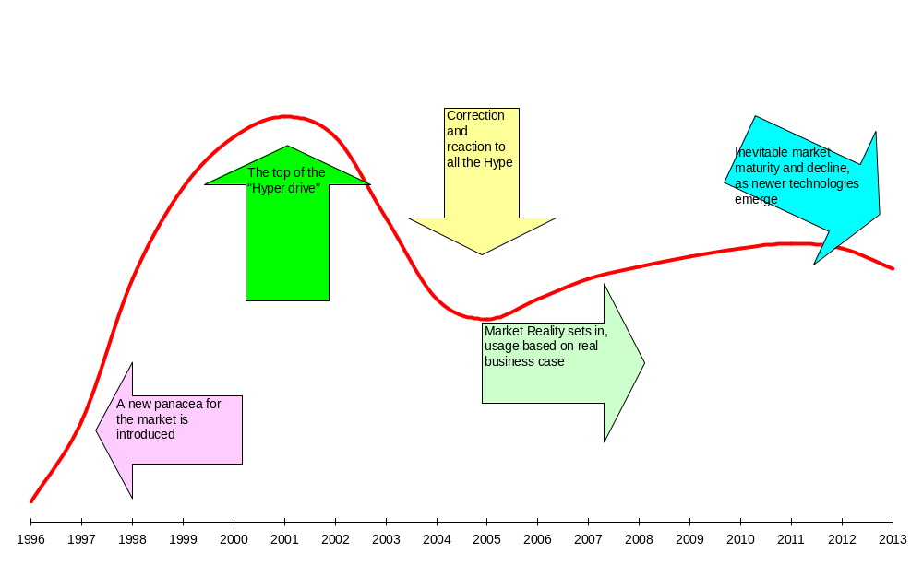
Whitehorse defined Typical IT Market Cycle
Source: Whitehorse Strategic Group Ltd own analysis

1.6 Prediction
Whitehorse consider that the Australian Outsourcing market growth will NOT continue at the high compound annual growth rates (CAGRs) predicted by many industry analysts, and may even retract from existing levels over time.
Outsourcing will not grow at the levels predicted
We also consider that the offshoring component of Australian IT outsourcing WILL grow for the next two years, but will also then level off from predicted CAGRs.
Offshoring will grow for 2 years, then level off

1.7 Economic effect
Outsourcing and offshoring have a distinct effect on employment, but they also have an economic effect on the Australian economy. One of the significant elements of economic effect is the economic ”leakage” related to repatriated profits, ie. that component of the ICT spend that is sent back to the international parent of the outsourcing company as profit.
Our analysis indicates that the sum of repatriated profits has had, and is continuing to have, a much higher economic effect on Australia’s trade balance than has been the case for repatriated jobs – ie. Offshore outsourcing. This is simply because the vast majority of outsourcing conducted within Australia is performed by overseas owned companies
Figure 2 below shows the relative annual economic cost to Australia of each of the three main types of outsourcing. The calculations are based upon a median 20% repatriated profit for Australian established overseas owned entities, a 20% retention in Australia for companies maintaining offices here, but performing most work offshore, and a zero percentage retention for the relatively small number of companies that perform offshore outsourcing without maintaining Australian offices.
Figure 2
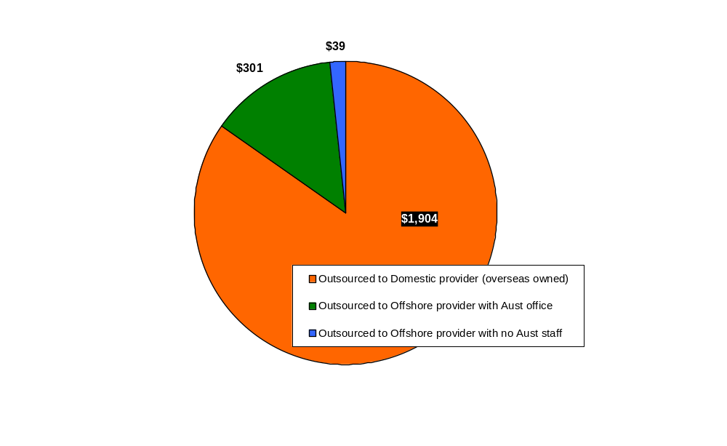
Economic Cost (A$’m) of Outsourcing by Type of Outsourcing Provider, 2001
Source: Centre for Strategic Economic Studies, Victoria University, Australian ICT Trade Updates; IDC Digital Planet 2002: The Global Information Economy, WITSA, February 2002.

As can clearly be seen, on these, relatively conservative, estimates from 2001, the negative annual economic effect of $1,904m on Australia from repatriated profits significantly outweighs the total current economic cost of offshoring (A$340m).
Outsourcing profits are more damaging than offshore employment

1.8 The economic offset – “Inshoring”
Any economic argument must also consider the impact of any offsetting effect, in this case “inshoring”, or the provision by Australian based companies of IT services to clients located outside Australia. For example if there are 100 jobs exported (or offshored), and 150 jobs imported (or inshored), then there is a 50 job net benefit to Australia.
Unfortunately, the available evidence suggests that the situation is more finely balanced than that. When we compare the economic cost figures in Figure 3 below with the gross IT services exports data, (ie. the value of “inshoring” jobs), then we find that, on currently available data, one almost balances the other.
This simply means that, unless Australia can increase IT services exports at a faster rate than it loses economic value through outsourced repatriated profits and exported jobs, Australia goes backwards economically.
Inshore employment can offset offshoring
Figure 3
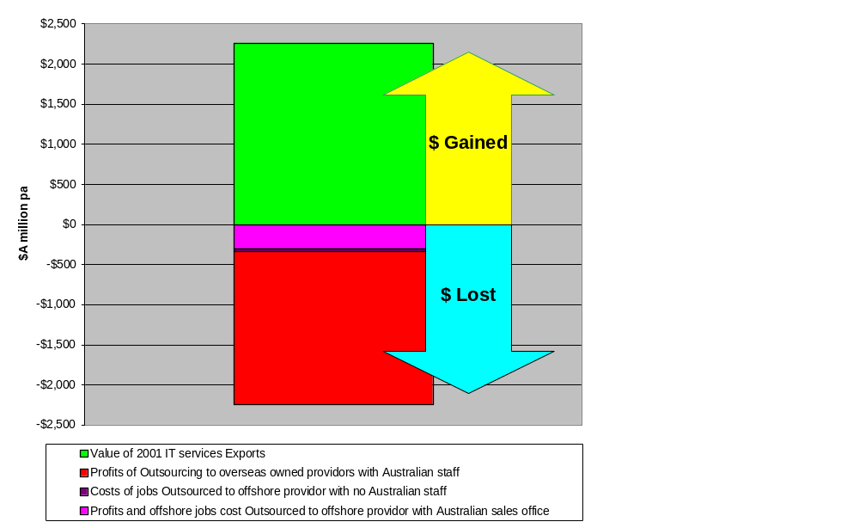
Net Economic Cost of Outsourcing in 2001
Source: Centre for Strategic Economic Studies, Victoria University, Australian ICT Trade Updates, IDC Digital Planet 2002: The Global Information Economy, WITSA, February 2002

1.9 The devil’s advocate
We would be remiss in this report, if we did not consider the arguments in favour of letting market forces decide outcomes. There are, we consider, five main arguments often put forward, these can be characterised as:

1.9.1 Change, Skills, Cycle, Demography, Temporary trend
The Change argument is simply that change is inevitable in any industry, that productivity gain and cost efficiencies in many other industries have been used as a justification for expenditure on IT for over thirty years, and that in Government administration, finance, manufacturing – including IT manufacturing, retail administration and many other industries they have all had to deal with change, redundancy, and dislocation – so why should IT be exempt?
All industries are subject to change, and better methods of operation should not be avoided. The question is one of appropriateness – how much IT process change to outsourcing and offshoring is being made for valid and sustainable cost-efficiencies, and how much is happening mainly to prop up share prices, to move expenses off the books, or to support political, rather than economic theory.
The Skills argument is that much of the unemployment and under-employment in IT is caused by people not having appropriate skills mixes; that too many have experienced the same year ten times, instead of ten years of experience; that they need a different skill mix; or that they have over-inflated salary expectations from too many years supervising rather than doing.
While there are some IT professionals who have not maintained the necessary skill levels, or learned necessary new skills, this needs to be weighed against years of practical experience and managerial expertise that would be difficult to replace.
The Cycle argument is that this year’s low cost location is next year’s mid-cost, and that the cycle continues until every country’s labour force has been exploited sufficiently to change the dynamic. There are question marks as to the length of the cycle, but, on this argument perhaps we can anticipate the USA as a low cost location by 2050, or thereabouts. In 2003, Indian programmers earn 16% of their Australian counterpart's wages, but this is predicted to narrow to 40% by 2015.
While the cycle argument essentially works in theory, the economic cycles may be too long for a sustainable IT industry to wait for heaven to come around.
The Demographic argument is that as the baby-boomers are flushed out of the job cycle, there will be a return to a more “normal” demography - so any problem will be solved in around five years.
Although this argument has some validity, it is small comfort to those who are destined for the scrap-heap in order to fulfil the argument. It is also based upon swiftly changing paradigms of duration of working life, which does not end, in IT, at 60-65 any more.
And then there is the Temporary trend argument, that is that the IT cycle has suffered a temporary downturn – SARS, war, terrorism etc, and is soon moving back into high gear, that this, in turn will drive increased demand for IT, and that this will re-establish the jobs growth that the profession and industry are used to experiencing.
This argument would be nice to believe in, but it is a little too facile. Yes the market may well improve, but does that mean that the patterns of consumption will also resume, probably not – as they never have before.
In addition to these, more canvassed arguments, we believe there is another factor that has significantly impacted outsourcing, and, especially its offshoring, the Panacea outsourcing effect.

1.9.2 “Panacea” Outsourcing effect
The significant rush towards outsourcing, especially by governments, over the last few years has been based in many cases, upon the mistaken concept that outsourcing is somehow a panacea for all IT ills. This has, we consider, led to a number of inappropriate outsourcing contracts.
Inevitably, when a market has been affected by the panacea mentality, corrections will later have to be inevitably made. This process can be seen by the increasing trend towards selective insourcing of processes or skills that were previously outsourced.
“Panacea” outsourcing continues to damage Australian IT
There is, however, another, probably unforeseen, effect from panacea outsourcing. Where the outsourcing originally undertaken did not, for whatever reason, provide the cost savings that were envisaged, there are inevitable pressures within the client organisation to seek out lower cost solutions within the same outsourced framework, rather than to acknowledge the original error and try to bring the process back within the client organisation. Figure 4 below shows the various stages in the lifecycle of a typical ‘Inappropriate ICT Outsourcing’ contract.

Figure 4
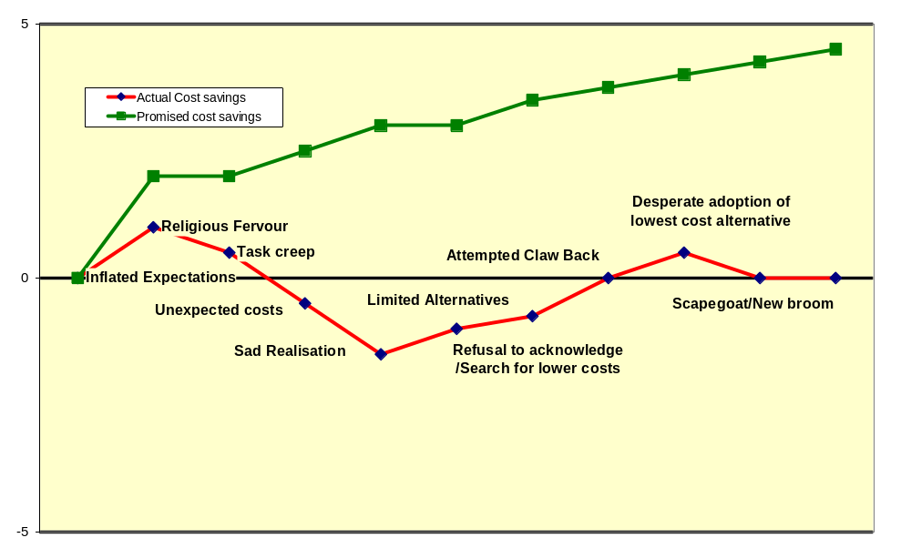
Lifecycle of an Inappropriate ICT Outsourcing Contract
Source: Whitehorse Strategic Group own analysis

In other cases, the original decision to outsource has created a condition in which the client simply no longer has the capacity to bring the process back to internal management, either through the loss of all skilled personnel, or by the loss of control of the necessary ICT infrastructure.
Our analysis indicates that a significant proportion of reported offshore outsourcing has emanated from already committed onshore outsourcing that failed to deliver the promised cost savings.
Companies unable to bring IT back inhouse, will turn to offshore in desperation
The question is, will more effective outsourcing decisions in the first instance simply dry up this “second-tier" offshore outsourcing market in the future.
This argument should, gradually, lose its impact, as the process cannot be continued indefinitely. Sooner or later, probably sooner, the demand for better service levels, speed of response, and quality of outcome, will require a re-assessment of services that have simply been chasing ever reducing costs.
IT Managers and other IT service purchasers will then find that the costs of re-establishment of required service levels and internal skills, may well outweigh the short-term cost cuts that they are currently claiming.

1.10 Outsourcing Key Findings
The key findings include:

- Outsourcing is currently overstated and hyped, and there is very little consensus on its true market position, nationally or internationally.
- Offshoring is also currently overstated and hyped, but we believe that it accounts for less than 4% (7,000 jobs) of the total IT Services market in Australia in 2003.
- Offshoring may grow to account for as much as 11,000 jobs over the next 5 years. If this were to occur, the additional 4,000 jobs lost offshore would result in A$450m in lost economic activity and A$135m in lost taxation revenue.
- ICT is now a global market, so offshore ICT outsourcing, in common with ICT global trade, will continue to grow from the current relatively low base.
- Currently, the jobs that are lost through offshoring of Australian ICT Services are marginally exceeded by those jobs gained from Australian offshoring for other countries (ICT Services exports).
- The economic losses of outsourcing go well beyond considerations of offshoring, and offshoring is a minor component of the loss.
- Some offshoring that is taking place is driven by a need to justify what were debatable decisions to outsource in the first place.
- There are considerable changes taking place in the cost-equations and other decision factors that lead to both outsourcing and offshoring, and these are leading to changes in business models including the greater use of collaborative and cooperative structures.
- India currently holds an estimated 80-90% of the global offshoring market, but other countries will challenge their market leadership.
- Graduate employment and remuneration have suffered in recent times, but it does not appear that offshoring has had any significant impact on this trend as yet.
- Australia is well placed to position itself as a global centre of high-end and high-value provision of architectural and project management type skills in the value chain.
- The ownership structure and focus of Australia’s ICT industry is changing, with a proportional increase in the presence of companies owned and headquartered in Asia. These companies should be just as welcome in Australia as European and American companies have been in the past.

2. Defining ICT Outsourcing

2.1 The Objective of the Study
A number of ICT industry stakeholders believe that there is a need for a comprehensive study to quantify and qualify Outsourcing, and the effect of Offshoring in Australia.
The primary objective of the study is to provide a critical assessment of the potential scenarios for ICT outsourcing and offshoring, both globally and in Australia.
This study has established:
- The types of ICT work and occupations already being offshored and what it is likely to be in the future.
- The extent that this offshored work is ‘entry-level’ ICT work and the implications this will have for graduates entering the market in the next five years and the long-term implications the removal of this layer of work will have for both ICT industry development and ICT education and training providers.
- The identification of factors that are unique to Australia which may effect the speed of outsourcing by Public and Private sector organisations in comparison to other Western countries.
The study has examined the following forms that offshoring can take:
- Offshoring to an overseas-based provider with no Australian presence;
- Offshoring to an overseas provider via its Australian-based office;
- Offshoring to an overseas provider via an independent broker; and
- Offshoring to a wholly (or partially) owned subsidiary of an Australian company or organisation located overseas.
The Report provides a global overview of the outsourcing market, with particular reference to offshore ICT outsourcing from Western countries in terms of spending, sectors, and the employment impacts, along with a detailed assessment of the current and projected size of the Australian-based ICT offshoring market.

2.2 Defining ICT Outsourcing
Information technology started in Australia over 100 years ago, with the establishment of the telegraph and later the telephone systems. Computers entered the equation in 1948, but an independent “IT” industry only started to be established in the late 1950’s and early 1960’s. Variously referred to as the IT or ICT or ITT industry, its structure and components are characterised by rapid change and significant definitional and classification problems that do not easily fit into traditional Standard Industry Classifications.
Outsourcing is not new
ICT Outsourcing is a relatively new term within the ICT industry and is often defined differently by analysts. It is thus important to establish what is meant by ‘outsourcing’. Outsourcing has become a commonly misused term, and much of the apparent disagreement over the merits and risks of outsourcing and problems with quantifying outsourcing, whether onshore or offshore, can be traced to differing definitions.
The ACS 1997 position paper states:
Outsourcing is essentially a how rather than a what term. It describes how IT services are obtained; not what the services are.
Outsourcing has been defined as:
"A contractual relationship where an external organisation takes responsibility for performing all or part of an agency's Information Technology functions. This can involve a partial or complete transfer of staff and/or resources."

This definition is in the context of public sector agencies, but could be equally applied to company outsourcing.
Outsourcing is:
"An arrangement whereby a third party provider assumes responsibility for performing information systems functions at a pre-determined price and according to pre-determined performance criteria."

2.3 The Outsourcing “market”
Regardless of the significant public pronouncements by industry watchers, there is not, in our opinion, a finite outsourcing “market”, unless one assumes that it includes the total of all IT services provided internally or externally to any client. What tends to be reported as an outsourcing “market” is assessments of how much of this total IT service market is currently, or is likely to be, provided by external vendors.
A specific outsourcing market does not exist
Published extrapolations on these current assessments tend to be either “straight line” or CAGR based. Whilst this is an appropriate approach to forecasting for defined markets, or where a market is being subject to gradual penetration, it is less likely to give an accurate picture in the case of outsourcing, where growth or contraction is related to the adoption or discarding of a behavioural pattern, with specific cost drivers.
As an indication of this contention, the growth in bureau services in the mid 1970’s, if projected by either straight line or CAGR, would have grown to now be equivalent to the entire IT industry gross. This did not happen, simply because the cost behavioural drivers for bureaux changed in the late 1970’s with the introduction of mini-computers.
Whitehorse therefore consider that the outsourcing trends may, over time, correlate more to a bell curve, than to a never-ending growth wave, and that the indication of the down-curve – or, at the least, flattening, will be variations in the cost-benefit equations that drive most outsourcing decisions.
The fact that there are definition issues surrounding the measurement of outsourcing is not unexpected when we examine the wildly varying estimates on the size of the global outsourcing market. All of the worlds leading research organisations have over time published their predictions on the market and there is no clear pattern or consensus of opinion.

3. Quantifying ICT Outsourcing

3.1 Introduction
The purpose of this Chapter is to use the data available from official sources to provide a global overview and status report on ICT outsourcing and offshoring from Western countries. We have used both published and unpublished data and modelling techniques to establish the size and future directions of the global market and impacts on the Australian industry.
The global Offshore ICT industry is claimed to have grown to be one of the largest industries in the world in terms of value added, production, foreign direct investments, exports and Research and Development. With many of the major outsourcing vendors owned by the US, this has seen the US claim to lead in the use of offshore destinations such as India and the Philippines, while other Western countries are beginning to follow the US lead. This US-centric view of the Universe does not necessarily correlate to the facts, however, as the UK utilisation of Indian based programming services, in particular, dates back to the 1970’s, well before the current hype started to develop.
Toss a coin and guess?

3.2 Estimates of Global Market Size
Globally, the ICT industry accounts for $US1.3 trillion in revenue, (4.1% of GDP) and grew at an average 7.1% over the 9 years to 2001, compared to average GDP growth rate of 3.5% over the same period.
The IT services and outsourcing components of this seem harder to estimate or predict. Figure 5 below shows the significant range of opinions. A listing of various Industry Analysts views are contained in Appendix One.
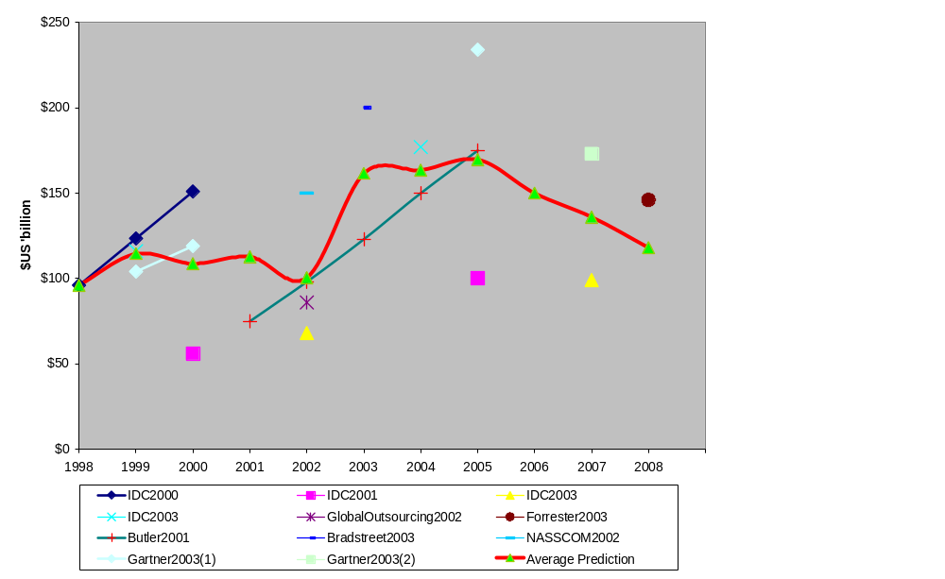
Figure 5
Predicted estimates (US$b) of worldwide outsourcing market by leading forecasters
Source: Various ICT research organisations’ forecasts - refer to Appendix One.
As can be seen, the level of variation is very significant, by factors of up to 250% for the same financial year. Some variations may be caused by differing interpretations of what IT Outsourcing is or includes, but it seems curious that there is such a variation between predictions in different years, or even from different offices in the same year from a single organisation, which, one would assume, would be using a consistent inclusion/exclusion formula
Figure 6 below simplifies the data above by simply showing the upper and lower bandwidth of the various “expert” predictions. Since the variation, in some years, exceeds the lower boundary, the best we can say is that there appears to be a wide divergence of opinion, and that a number of commentators have changed their minds rather frequently.
Figure 6
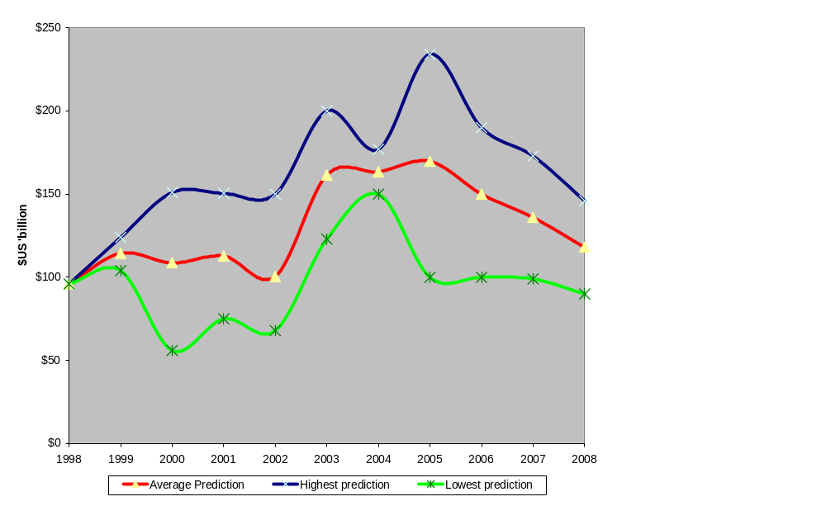
Predicted estimates (US$b) of worldwide Outsourcing Market by Leading Forecasters
Source: Various ICT research organisations’ forecasts - refer to Appendix One.

3.2.1 Offshore quantification
Forecasts of the offshore component of this outsourced IT services market also vary, but appear to be equally optimistic, refer to Table 1 below.
Table 1
Forecast of Global ICT Offshore Market
Year | Revenue (US$’m)
2000 | $12,400
2001 | $17,000
2002 | $23,000
2003 | $31,000
2004 | $40,000
2005 | $50,000
CAGR | 32.2%
Source: Butler Group ‘Strategic Sourcing Report’, October 2001.
Indian technology stock prices, however, do not seem to reflect the optimism of an offshore outsourcing market growing at these levels for the foreseeable future. The Indian BSE-TECk technology index has closely followed the NASDAQ over the last 2.5 years (refer to Figure 7 below). This indicates that the stock market in India is yet to factor in the potential growth prospects for the outsourcing market and is very much focused on the US market. The decline in the NASDAQ has impacted US corporations’ offshoring activities and this has had a ripple effect to the share prices of Indian outsourcing companies’ stocks.
Figure 7
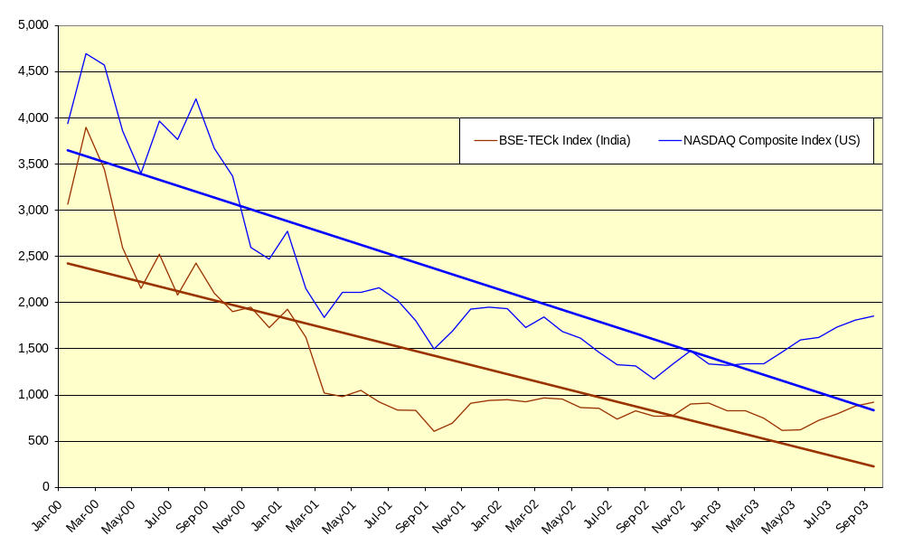
NASDAQ and BSE-TECk Stock Indices, January 2000 – September 2003
Sources: Bombay Stock Exchange (BSE), New York Stock Exchange.
Another, more sober viewpoint is seen in US Department of Commerce data, which also does not seem to share the wild enthusiasm of some of the more widely quoted experts, see Table 2 below.
Table 2
US Offshoring of ICT services, 1990-2000
Year | Value of US Outsourcing IT services to other countries (US$b) | Value of Offshore Outsourcing IT services into US (US$b) | Balance of Trade in IT services (US$b)
1990 | $1.0 | $0.0 | $1.0
1994 | $1.3 | $0.1 | $1.2
1995 | $1.3 | $0.1 | $1.2
1996 | $1.6 | $0.3 | $1.3
1997 | $2.0 | $0.6 | $1.4
1998 | $1.9 | $0.8 | $1.1
1999 | $2.7 | $0.9 | $1.8
2000 | $2.5 | $0.8 | $1.6
Source: US Dept of Commerce, Digital Economy 2002, Table 6.2 US Trade in IT Services

4. Qualifying IT Outsourcing

4.1 Factors Affecting the Global Market
The primary factor driving offshoring that is normally quoted is that of Software development costs, which, for example, in India are estimated to be 30-40% lower than those in developed markets (eg. USA) (Lacity and Hirschheim, 1995).
Table 3 below however shows that there are expected to be significant percentage increases in programmers salaries by 2015 in some countries where the current salaries are quite low. Significantly the increase in the United States, Japan, and Australia is only in the range of 14-17% over the next 12 years which shows the consolidation of salaries globally. Where the US programmers are paid 10 times more than Indian programmers today, by 2015 they will be paid only 4 times more (assuming US$ parity).
Table 3
Predicted Salaries for programmers by 2015 – Selected Countries
Country | 2003 Programmer Salary (US$) | Predicted 2015 Programmer Salary (US$) | Predicted % growth 2001-2015
China | $5,850 | $10,000 | 71%
India | $6,350 | $20,000 | 215%
Philippines | $6,550 | $9,000 | 37%
Malaysia | $6,950 | $9,000 | 29%
Russia | $7,550 | $25,000 | 231%
Poland | $9,000 | $45,000 | 400%
Australia | $38,600 | $45,000 | 17%
Japan | $30,350 | $35,000 | 15%
United States | $74,500 | $85,000 | 14%
Sources: Janco Associates September 2003, CIA World Factbook, Lane S. ‘Offshore software development: Localization, globalisation and best practices in the evolving industry’ Aberdeen IT services Practice, Aberdeen Group, November 2001. Australian salary from the Australian Computer Society Remuneration Survey Reports.
The projected rise in the wages of Indian ICT workers will see the average salary for an Indian programmer increase in proportion to other countries. In 2001 Indian ICT workers were paid only 16% of their Australian counterparts wages, but this will increase to 44% by 2015. This will most likely have a marked effect on the competitiveness of India as an offshoring destination and will cause companies to reassess the business case for offshoring.
Convergence in international ICT services salaries
Figure 8 below illustrates the convergence of wages effect, showing that the current wage price advantage that India enjoys is predicted to decline over time. The chart also highlights that the average programmer salary of all the ‘new offshoring contenders’ will become 2% cheaper than India by 2015.

Figure 8
Indian Programmer salary as a percent of salaries in other countries
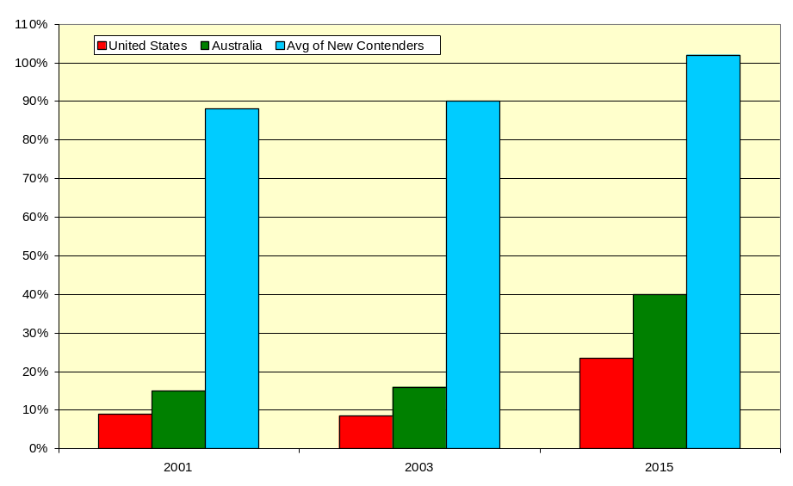Sources: Janco Associates September 2003 CIA World Factbook, Lane S. ‘Offshore software development: Localization, globalisation and best practices in the evolving industry’ Aberdeen IT services Practice, Aberdeen Group, November 2001, Australian Computer Society Remuneration Survey Reports.

4.1.1 “Cycle Theory”
This analysis is clearly consistent with the concept of comparative advantages operating in cycles. Some further evidence for this theory can be found in two recent predictions. Firstly that by 2010 it is anticipated that only 10% of the US economy will be in manufacturing (Unite, apparel workers Union), and secondly US Census Bureau data indicating that both median household income and per capita income declined in the US in the period 2001-2 for the first time since 1991, whilst the poverty rate rose in the same period to be 12.1% of the US population (over 34 million people).
The decline in the US dollar conversion rate to other currencies since then amplifies this change, and leads to the potential of a continuing decline in the relativity of wage rates between the US and other countries over the next ten years.
Global economic cycles
Figure 9 and Table 5 below provides Whitehorse’s current assessment of the competitive advantages of countries that are potential suppliers of offshore ICT services. In Table 4 that also follows Gartner has similarly categorised countries by their assessment of their offshoring status. Both sets of information provide a picture of an offshoring market that is currently dominated by India, but in which there are a number of countries emerging as realistic and competitive alternatives to India. The competition to win a share of the lucrative global offshoring market will only intensify over the next five years as this “new industry” matures.
Australia with a large ICT services workforce that has excellent English language and technical skills, coupled with a favourable geopolitical environment is well placed to attract a share of the global offshoring market. Whilst Australia has relatively higher paid workers than most of the other destinations presented, there has been some wage growth restraint in the last two years, and there will be wages growth in the countries that currently have a low paid ICT services workforce. In Whitehorse’s opinion this will make Australia an attractive and viable destination to base global operations.
Figure 9
IT Outsourcing Comparative Advantage Indicators
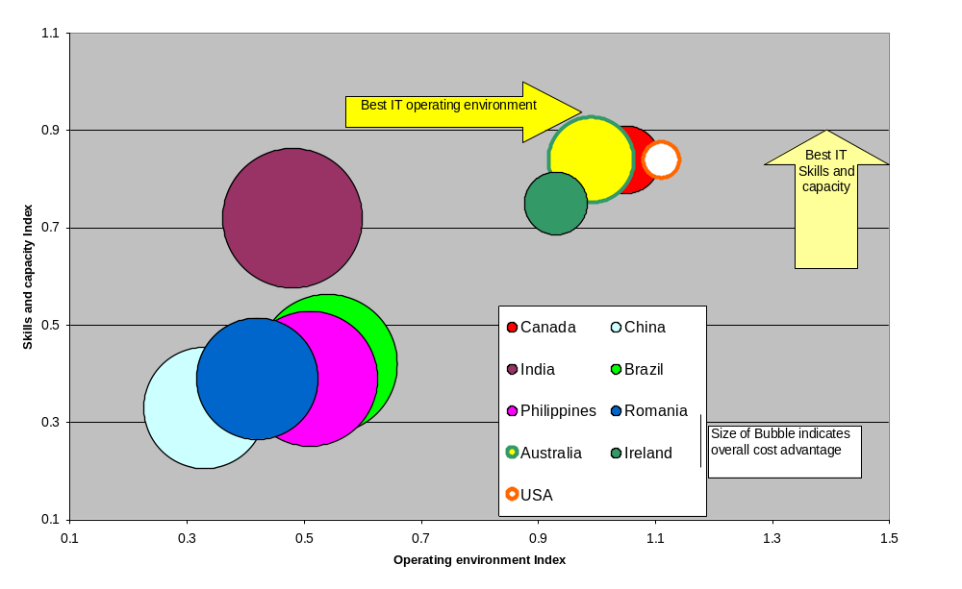
Source: Whitehorse Strategic Group own analysis.

Table 4
Global Offshoring Locations and Status
Status | Country
Leader | India (Holds est. 80-90% of the global ICT services offshore market)
Challengers | Canada, China, Czech Republic, Hungary, Ireland, Israel, Mexico, Northern Ireland, Philippines, Poland, Russia, South Africa.
Up and Comers | Belarus, Brazil, Caribbean, Egypt, Estonia, Latvia, Lithuania, New Zealand, Singapore, Ukraine, Venezuela
Beginners | Bangladesh, Cuba, Ghana, Korea, Malaysia, Mauritius, Nepal, Senegal, Sri Lanka, Taiwan, Thailand, Vietnam
Source: Gartner Press Release, April 2003

It is difficult to see any of the countries listed in the ‘Up and Comers’ and ‘Beginners’ categories of the table becoming major players in ICT offshoring in the next 5-10 years. They simply do not have an existing sizeable base of skilled ICT professionals, unlike India and some of the countries in the ‘Challengers’ category. It is perhaps surprising that Gartner does not list Australia under any of the categories, however lists Singapore and New Zealand as “Up and Comers”.
Figure 10
Matrix Evaluation of offshore suppliers capabilities
Good English and Low Wages  “Cost advantages are eroding”  - Bulgaria  - Philippines  - India  - Pakistan  - Egypt | Good English and Average Wages  “Stuck in the middle -  potential player”  - South Africa | Good English and High Wages  “High quality, current  wage restraint”  - Canada  - Australia  - Ireland  - Israel
Average English and Low Wages  “Emerging low cost force”  - Malaysia | Average English and Average Wages  “Potential to grow through reduced costs”  - Thailand | Average English and High Wages  “No comparative advantage in price or quality”  - Singapore  - Argentina
Poor English and Low Wages  “Quality risks”  - Poland  - Hungary  - Czech Republic  - Vietnam  - China  - Russian Federation  - Romania  - Brazil  - Mexico  - Chile  - Venezuela | Poor English and Average Wages  “Positioning Problems”  - Ukraine | Poor English and High Wages  “No mans land – expensive with low quality”  - South Korea
Note: Within each quadrant, countries are listed in order from lowest to highest Geopolitical Risk.

Source: Whitehorse Strategic Group’s own analysis

4.1.2 India –the leading provider of Offshore ICT services – Why?
What are the factors that make India so attractive today as an offshore destination:
It appears that the main factors are:
- The decision by Indian companies since the 1970’s to actively target offshore revenue
- Strong selling of cost market advantages
- The significant and growing number of ICT professionals employed, see Table 5 below.

Table 5
ICT Workforce Employment in Australia and India, Selected Years
 | 1997 | 2000 | 2001 | 2002 | 5 Year % growth
Australia | 246,500 | 262,800 | 282,000 | 296,100 | 20%
India | 160,000 | 284,000 | 430,114 | 522,250 | 226%
Sources: Indian National Association of Software and Services Companies and ABS Labour Force Survey unpublished data
In terms of the leaders in the outsourcing market, the top five ICT services providers dominate the sector in Australia, US and India, refer to Table 6 below.
Table 6
Top 20 ICT Service Providers by Revenue – Selected Countries, 2002/03
Rank | Australia | USA | India
1 | IBM GSA | IBM | Tata Consultancy Services
2 | EDS Australia | EDS | Infosys Technologies
3 | CSC Australia | CSC | Wipro Technologies
4 | Hewlett Packard | First Data | Satyam Computer Services
5 | Fujitsu Australia | ADP | HCL Technologies
Sources: NASSCOM Press release July 17 2003, ‘NASSCOM announces Top 20 IT Software and Service Exporters in India’; Pierre Audoin Consultants - www.pac-online.com; Whitehorse Top 250 ICT Industry Survey.
It is important to note that the aggregate revenues by the top five companies in Australia and India, are minuscule compared to those of the top five companies in the US.
- The top five ICT services companies in Australia had combined revenues of AUD$6,925m in 2002/03, down 1.0% on 2001/02.
- The top five ICT services companies in India have combined revenues of US$3,052.9m in 2002/03.
- The top five ICT services companies in the US had combined revenues of US$43,155m in 2002, up only 1.0% on 2001.
Other major ICT services vendors in Australia include: Volante Group, KAZ Group and Solution 6.

4.1.3 Scale and Type of Work moved Offshore

Four key areas suited for offshore:
Data conversions and system migrations are typical projects taken offshore as they can have well-defined requirements and specifications with minimal end-user interaction with the development team.
Applications development particularly the construction and testing phases of the System Development Life Cycle (SDLC) where end-user interaction is limited and the task well-defined.
System maintenance for stable applications.
Call Centre and Help Desk functions.

ICT Business Processes that may be outsourced:
- Facilities Management;
- Systems Integration;
- Managed Networks, Managed data services;
- Managed ASP;
- Data hosting, Web hosting;
- Data storage, Content storage;
- Data centres, telehousing;
- Customer Relationship Management.

A NASSCOM study of the ICT workforce in India found that the following skills were in demand and indicates the current and future areas of focus for offshoring:
- Software engineering/programmers/analysts;
- Internet and e-commerce applications;
- Database administrators;
- Network specialists and communication engineers;
- Digital media;
- Business applications of software development;
- Web based applications;
- Networking applications;
- Java;
- Data warehousing;
- Client-networking;
- Project management;
- Quality assurance and technical writing;
- Legacy systems.
Source: NASSCOM Manpower Resources Survey 2001-02.

As India currently hold 80-90% of the global offshoring market it can be assumed that this list of skills in demand is indicative of the type of ICT work that is and will be moved to offshore destinations.

4.1.4 Different models of ICT outsourcing
There are a number of different models that are applied to ICT outsourcing. They include the following:

Model | Operational Impact
Offshore company operates without an Australian presence. | Differences in time-zones can cause communication issues and most communication is done via email and telephone which makes it difficult to establish strong working relationships with customers. Reliability and security become issues with this model. The impact of this model on Australia is that there are no jobs retained in Australia
Offshore Company operates with only an Australian ‘sales’ office. | The company is able to offer lower rates than the Australian vendors put the local sales office customer service is limited by their lack of technical expertise. The lack of visibility to the project team and facility can again raise issues around reliability and security. There is only negligible employment through the business development staff located in Australia. Revenues earned and jobs flow back to the offshore company.
Offshore company operates with an Australian office and Australian staff. | Under this model the outsourcer offers higher rates but they are able to respond to customer requests much more quickly and easily as the local project managers team up with both the Australian and offshore technical resources. This model has the best impact for the local industry with jobs growth and flow on economic benefits realised.

It is increasingly evident that whilst “Offshoring” companies may enter Australia on the presumption that they will be working to similar models to that used in the US or Europe, that the economics and market requirements are different in Australia, and that a more flexible approach, in many cases with a greater local presence, is often the only way to do effective business here.

4.1.5 Composition of Offshored IT work
We are advised that the type of work that is currently being offshored is either of a “low” or “high” skill in nature, as most of the occupations in the “medium” skill level are not suited to offshoring as there is a greater need to have a physical presence at the client’s site for these types of occupations. Table 7 below classifies various ICT occupations by the skill level.
Table 7
Classification of ICT related occupations by level of skill
Skill Level Required | ICT Occupation
High Skilled ICT occupations | Computer support specialists  Computer software engineers, applications  Computer systems analysts  Computer programmers  Computer software engineers, systems software  Computer and information system managers  Network and computer systems administrators  Engineering managers  Electrical and electronic engineering technicians  Network systems and data communication analysts  Database administrators  Electrical engineers  Electronics engineers, except computer  Computer hardware engineers  Computer and information scientists, research
Medium Skilled ICT occupations | Data entry keyers  Electrical and electronic equipment assemblers  Telecommunications line installers and repairers  Computer, ATM, and office machine repairers  Electrical power-line installers and repairers  Telecommunications equipment installers and repairers, excluding line installers  Electrical and electronics repairers, commercial and industrial equipment  Semiconductor processors  Electromechanical equipment assemblers
Low Skilled ICT occupations | Billing and posting clerks and machine operators  Switchboard operators, including answering service  Mail clerks and mail machine operators except postal service  Computer operators  Office machine operators, except computers  Telephone operators
Source: OECD eBusiness and ICT Skills in Europe, June 2002

4.2 Factors driving Offshoring
The “normal” reasons for offshoring are the same as those applying to outsourcing in general. Table 8 below highlights commonly cited reasons for outsourcing ICT services.
Table 8.
Top Ten Reasons Companies Outsource ICT Services
Top ten reasons companies outsource
1. Reduce and control operating costs.
2. Improve company focus.
3. Access world-class capabilities.
4. Free up internal resources for other purposes.
5. Resources are not available internally.
6. Accelerate re-engineering benefits.
7. Function difficult to manage or out of control.
8. Make capital funds available.
9. Share risks.
10. Cash infusion.
Source: The Outsourcing Institute, United States, 2003
But we consider that there are some additional more specific reasons:
- Fashion – offshoring as the ‘in’ trend.
- Assumed Cost savings over local outsourcing.
- Improved capacity to move capital expenditure items off the balance sheet.
- Requirement to cater to Share market perceptions (that a company working to lower costs must mean that it is well managed and that this leads eventually to higher profits), this perception then helps to lift the share price.
But there should, equally be some major concerns:
- Cost savings may not materialise.
- Speed to market – timeliness, may suffer.
- Quality control becomes more difficult.
Companies that use offshore outsourcing may also face issues around data management and security as the sheer physical distance between the user and network management staff makes the task more difficult.

4.2.1 Growth and change in Offshoring
We believe that Offshore outsourcing in Australia will continue to grow over the next few years as companies look to external vendors to help them reduce their costs by managing IT infrastructures, developing and maintaining applications and providing support services. The reasons for companies looking at offshore outsourcing arrangements identified in the previous section highlight why business and government see this as an attractive option in the present times.

In the press recently there has been increasing debate on the issue of offshoring and this can reasonably be expected to increase as the industry faces pressure to become more cost conscious.
Offshoring may promise companies lower cost bases, but companies will need to deal with potential negative publicity, as customer’s become dissatisfied with poor service. Vendors competing for large mega outsourcing deals will look to use more and more offshore bases to lower their cost positions in an attempt to win business on the grounds of cost more so than quality service basis. It is reasonable to assume that in the tight global IT market at present the focus is on IT cost reduction.

Once the cycle turns and investment in ICT becomes important as companies see ICT as enabling growth, the operating focus will shift away from lower costs to such things as quality service delivery, speed to market, innovative product development and the like, in order to remain competitive. In the upcycle this will place increasing pressure on vendors locked into low cost delivery contracts, they will face decreasing profitability and face difficulty in hiring and retraining enough staff to keep up in a more buoyant market.

However, the CEO of Kanbay, a major Indian outsourcer says India has been very good at learning and understanding US and European markets and figuring out how to adapt operations. “We work slightly different hours depending on the client. You have to be flexible. It takes that kind of adaptability to be successful”. Source: The Australian October 7, 2003 Diana Thorp “Kanbay seeks to tap local talent”.
New operational models emerging

We therefore believe that Indian companies will increasing look to acquire or partner with Australian 2nd tier companies as a way of entering into the Australian market to secure work to send back to India. This approach may lead to integration issues for those companies in the short term.

Offshoring will increasing feature in major outsourcing contracts so that the vendors can maintain their margins. Indian offshoring vendors experienced considerable growth recently (ie. the top 8 offshore vendors in India experienced revenue growth of 30% between 2001 and 2002) but this growth may begin to slow as they face some hurdles. Some of these hurdles include:

- Operating margins are falling as wages increase and the US dollar begins to decline, leading some major offshoring vendors to revise downwards their aggressive growth forecasts.
- Other countries like China and the Philippines are beginning to slowly emerge as competitive alternative destinations to India for offshoring.
Competition amongst offshore suppliers is increasing
- The major global ICT service providers are also beginning to establish larger offshoring development centres, which has lead to an overall increase in competition in the offshoring market.
- Governments and large corporations that use offshoring as a component in their outsourcing contracts are starting to experience some political backlash with protests and new legislation to restrict offshoring also proposed in some States in the US.
- Tax privileges enjoyed by offshore suppliers may begin to be neutralised as other countries begin to offer similar favourable concessions.
The Indian government has offered tax incentives to attract foreign investment in ICT. The importation of IT related capital goods are duty free (instead of attracting the normal 25-45% tax) in India. Outsourcers of technology are also allowed a full tax exemption on the export of their services from India.

The Indian government indirectly subsidises foreign investments by also exempting taxes on profits. Valued Added tax (VAT) is not applicable for the purchase of IT equipment and services and the depreciation rates on IT equipment are also high at 80 per cent of the written down value for the first two years and then a rate of 60 per cent applies.

Whitehorse feels that the tax incentives offered by the Indian government will not be sustainable in the long run, or that other countries will match them.

Whilst two way trade in computer and information services between Australia and the European Union (EU) made up only 1.5% or A$203m in 2001-02, it has shown very solid trend growth of 10% per annum over the five years up to 2001-02. Source: Delegation of the European Commission to Australia and New Zealand, September 2003 Background Newsletter.

Whitehorse consider that sustainable growth for Australia in the provision of IT services can be derived from the growing EU market.

5. The Australian IT Context

5.1 Introduction
ICT production in Australia is approximately 8% of GDP – twice that of the entire Australian rural sector, and the average annual growth rate of ICT industry production was 12.2% from 1995-6 to 2000-1, compared to the average annual GDP growth rate of 4.1% over the same period.

Table 9 below provides a high level overview of the ICT Industry in Australia. All data as at 30 June 2003, unless otherwise stated.
Table 9
Key ICT indicators for Australia, 2003
Key Indicators | Australia
ICT Profession Employment | 298,700
ICT Industry Employment | 196,600
ICT Industry Employment as % of All Industries FTE Employment | 2.9%
Employment in the ICT industry per 1,000 Employed Persons | 21
Proportion of the ICT Industry working for an Aust-Owned company | 46%
ICT Industry Revenue | $61.8 billion
Revenue generated per ICT industry employee | $314,000
Economic Value Add of ICT Industry | $13 billion
ICT R&D Expenditure (‘Top 250’ ICT companies only) | $603.0 million
ICT R&D Expenditure per ICT Industry Employee | $3,100
Public Sector ICT R&D Expenditure, 2001-02 | $148.1 million
Value of ICT Equipment Exports (excluding re-exports), 2001-02 | $1,499 million
Value of ICT Equipment Imports, 2001-02 | $16,799 million
Students studying IT courses at University, 2002 | 79,085
Sources: Whitehorse Top 250 Survey series, ABS, Tradedata
As with the global market, estimates of the Australian IT services and Outsourcing market vary considerably. In the main we find estimates of IT services a lot more believable than estimates of Outsourcing. Table 11 shows estimates of the size of the Australian IT services market.
Table 10
Australian IT Services Forecast, 2003-2008
 | 2003 | 2004 | 2005 | 2006 | 2007 | 2008
IT Services Expenditure (A$’m) | $14,115 | $16,333 | $18,900 | $21,871 | $25,309 | $29,287
Total Australian IT Expenditure (A$’m) | $87,345 | $96,564 | $106,758 | $118,027 | $130,486 | $144,259
IT Services as % of Total IT Expenditure | 16.2% | 16.9% | 17.7% | 18.5% | 19.4% | 20.3%
Source: Digital Planet 2002: The Global Information Economy, WITSA, February 2002. Converted to $A by Whitehorse Strategic Group using average annual exchange rates, extrapolated using CAGR.
“The Australian IT Services outsourcing market experienced 29% growth in 2001 growing by A$3.8b, it reached A$4.3b in 2002 and is expected to be A$6.3b by 2006 with a CAGR of 10.4%. IBM GSA, EDS and CSC together held 76% of the total IT services outsourcing market in Australia in 2001. The top 10 by revenue were: IBM GSA, EDS, CSC, Compaq, Fujitsu, KAZ, HP, Unisys, Telstra Enterprise Services, and Ipex”. Source: IDC Report, 2002, ‘Australian IS Outsourcing Forecast and Analysis 2001-2006’.

Leaving aside the initial line, this prediction forecasted a growth rate of 10.4% per annum, This is a good rate, but not a startling one, but the prediction also presumed that it will be sustained over five years.

5.2 ICT Employment in Australia
The ABS Labour Force Survey data estimates that there are 298,700 ICT professionals employed in Australia in August 2003. Whitehorse data from June 2003 indicates 197,000 Full Time Equivalent employees in the ICT industry, of which, we estimate, over 70% are ICT professionals. Refer to Table 11 below:
Table 11
Number of employed ICT Professionals in Australia, August 2003
ICT Occupation Classification | No. Employed
Electronic Engineering Associate Professionals | 14,400
Electrical and Electronic Engineers | 22,700
Communications Tradespersons | 26,800
Information Technology Managers | 26,900
Computing Support Technicians | 32,400
Computing Professionals | 175,500
Total ICT Professionals | 298,700
Source: Australian Bureau of Statistics, Labour Force Survey unpublished data.

Figure 11 that follows shows the number of employed and unemployed persons classified as “Computing Professionals” (ASCO code 2231) over the past two years. The chart highlights the relatively flat employment position, although the proportion of ‘Computing Professionals’ who are unemployed remains higher than the unemployment rate for other Professional groups.
Figure 11
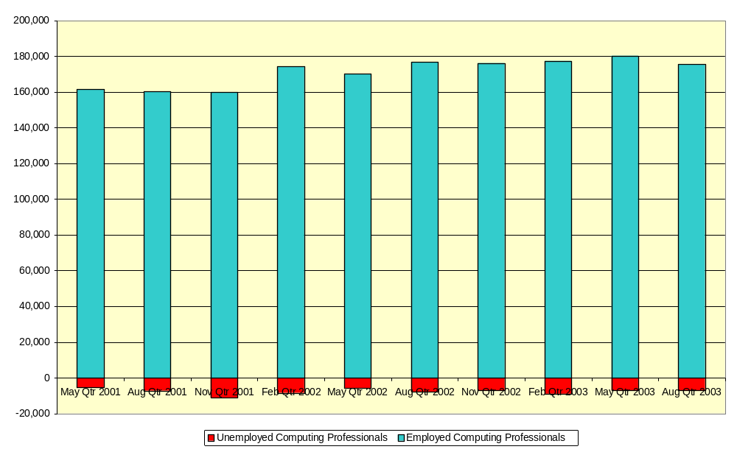
Number of Employed and Unemployed Computing Professionals

Note the data only includes counts of the ASCO classification code 2231 ‘Computing Professionals’, which normally accounts for 60% of total ICT employment and unemployment.
Source: ABS Labour Force Survey unpublished data.

Two studies undertaken by the Australian Computer Society in 2002 and 2003 of its 13,000 members have underscored this position. The ABS definition of employment includes many people who would self define as unemployed or underemployed. The ACS survey and analysis estimated that in 2003 10.6% of its members considered themselves to be unemployed or underemployed. It is perhaps noteworthy that the higher percentages of unemployment by category in these surveys tended to fall into Programmer/Software Engineer/Project manager categories – NOT low end work, and that the higher percentages of unemployment by industry were found in Communications; Banking/finance; Public Administration, and Consulting – all sectors with higher Outsourcing participation.

5.2.1 Offshoring Employment Composition
Whitehorse estimates that approximately 7,000 ICT jobs have been lost offshore to June 2003, based upon the average employees per $Million revenue in this sector of the Australian IT industry, extrapolated from the value of ICT services trade.
This represents approximately 2.3% of the total ICT professional employment in Australia, or 3.9% of total ICT professionals in ICT services.
Figure 12 following, highlights the number of jobs lost offshore relative to total ICT employment in Australia.
Figure 12
ICT Employment in Australia and Whitehorse estimate of ICT jobs lost Offshore to June 2003

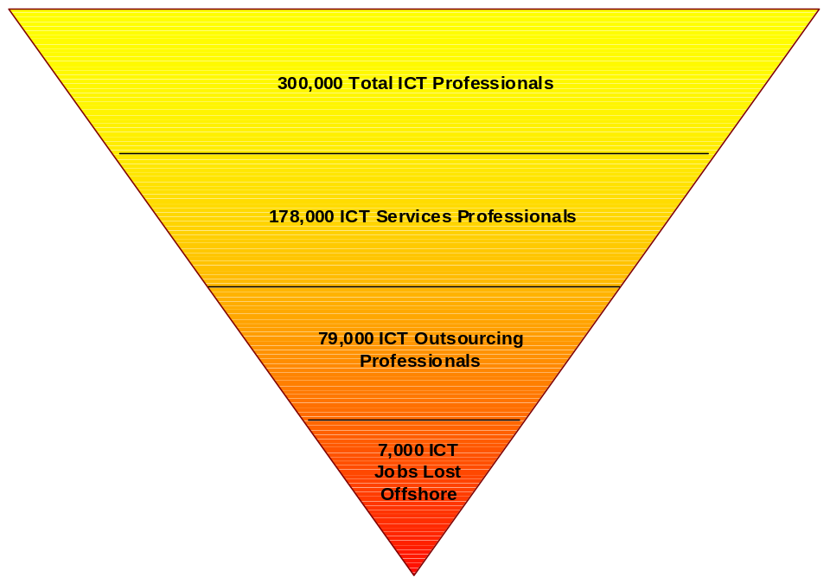

Source: IDC, Tradedata 2001 and Whitehorse Top 250 Survey and Modelling June 2003, Australian Bureau of Statistics Labour Force Survey August 2003.

5.3 Australian Factors influencing trend towards Offshore Outsourcing
The factors identified under Section 4.2 driving offshoring also apply to the Australian context, however there are some unique factors to the Australian market.

5.3.1 Government support of Outsourcing
Approximately a third of all IT&T expenditure by the Federal Government is outsourced. Source: Paul Budde Communications, Australia Industry Outsourcing Report, September 2003.

As far back as July 1997 the ACS in a media release advocated that the Federal Government use caution with regards to whole of government outsourcing. The then ACS President, Tom Worthington said "Whole of government IT outsourcing is a high risk approach, for individuals, organisations and for the community as a whole. It is important that all those involved understand their obligations and the risks, as well as the potential benefits”. Source: ACS Urges Caution on Whole of Government IT Outsourcing, Media Release, Friday 11 May 1997, Canberra.

The 1997 ACS position paper on outsourcing ‘Outsourcing and contracting out of IT products and services’ also highlighted the issue of "Whole of government" IT outsourcing as a high risk approach. “There are risks due to the large scale, long lead times, potential loss of services across government and differences in agency requirements. There may be difficulties in the Australian IT industry absorbing large outsourcing contracts. Other approaches might be used to achieve the desired cost benefits, with lower risks and to permit the Australian IT industry to benefit”.

“Some case studies of outsourcing in public sector organisations indicate that public sector information systems can be critical, complex and volatile, due to the nature of political decision making. This makes outsourcing less attractive. Recent indications are that the Australian Government understands that outsourcing should not be chosen just to circumvent inflexibilities in the public sector accounting systems”.

“Outsourcing assessment processes are a valid tool for Government and private organisation in matching operations to strategic needs. However, particularly in the case of government there is a need for processes to be open, accountable and participatory. Decisions made behind closed doors and communicated as a fait accompli are not in the public interest.”

These early warnings by the ACS and others are now tending to be, unfortunately, borne out, but are, in some cases translating into an increased tendency to consider offshoring, both by Government owned bodies and others that adopted similar approaches.

We consider that this can be illustrated by the model in Table 12 below.
Table 12
Diary of an Inappropriate ICT Outsource Contract
Inflated Expectations | Oversold benefits lead to a presumption that significant cost savings will be accompanied by improved service levels in all cases.
Religious Fervour | Organisations adopt inappropriate or badly structured outsourcing deals, based upon the mistaken concept that outsourcing is a panacea for all IT ills, or will achieve other organisational goals.
Sad Realisation | Claims of significant cost reductions are found to have been absorbed and exceeded by specification creep and unforeseen expenses, and, in many cases, client service levels have dropped below acceptable levels.
Refusal to acknowledge / Search for lower costs | There is a strong inclination within the client organisation to seek out lower cost solutions within the same outsourced framework, rather than to acknowledge the original error and try to bring the process back within the client organisation.
Limited Alternatives | Unfortunately the client simply no longer has the capacity to bring the process back to internal management, either because of the loss of skilled personnel, or of control of the necessary ICT infrastructure.
Attempted Claw Back | However there may be an increasing trend towards selective insourcing of processes or skills that were previously outsourced, and a breaking down of mega-contracts into smaller deals.
Desperate adoption of lowest cost alternative | Those organisations still in denial keep on trying to achieve the promised cost reductions by pursuing offshore outsourcing, mainly by renegotiating already committed onshore outsourcing that failed to deliver the promised cost savings.
Scapegoat / New broom | When there is nowhere left to go, someone will have to be found to be blamed, and someone else will take the credit for discovering a completely new approach to client service.
Source: Whitehorse Strategic Group own analysis.

Australian Governments are now looking to shift away from long-term contracts to more selective outsourcing, which potentially provides more flexibility. The whole of South Australian government EDS contract and the Australian Taxation Office are two examples where this is beginning to occur.

5.3.2 Uniqueness of the Australian ICT marketplace.
There are some specific factors that make Australia different to the US and other markets, from which most of the outsourcing paradigms are derived. They include:

- Isolation
- high quality education
- high wages for lower skilled workers
- favourable exchange rate
- resourceful workers
- high productivity
- high R&D innovation amongst Australian owned companies
- clean
- politically stable
- organisation culture is to generally use small teams
- resources and skill sets spread right across the value chain.

IT departments within organisations in Australia sometimes suffer from not being able to define how much value they deliver for the business. Where there is widespread negative perceptions of an IT department, this has a bearing when senior management consider whether or not to outsource. The decision to outsource may then be made not purely from a cost saving basis but from a desire to sidestep the IT department that in their perception is not performing.

In our consulting with industry for this project we discovered that large corporations in Australia generally do not consider or invite bids from 2nd tier providers when making decisions to outsource ICT services. As such the 2nd tier firms (which comprise a number of Australian owned companies) are largely not using offshoring models in their bids, as they are concentrating on the smaller corporations and SMEs, where the scale of operations does not suit using offshore locations.

Software Engineering Australia (S|E|A|) recently released the results of an independent survey “What’s Bugging Australia’s Software Industry? 2003 Report”. Respondents from the software industry were asked to rank issues and their level of concern. The issue of offshoring had an overall ranking of seventh in a list of areas seen as a threat to the domestic industry. From this we can conclude that whilst offshoring is viewed as an area of concern by software industry professionals, it is far from the top issue of the day, which from some of the recent media hype on offshoring, would have us believe to be the case.

6. Impact of Offshoring on ICT Employment Growth in Australia

6.1 Implications of IT Offshoring
IT offshoring has an impact on IT employment in three significant ways:
- Loss of future talent;
- Loss of intellectual assets;
- Loss of organisational performance;
But the quantum of these impacts are directly related to the relative proportion of jobs lost to the overall IT employment picture.
Figure 13 below is derived from both an analysis of the employment implications of ICT expenditures, and comparison to ABS labour force statistics for IT professionals. Both results equate to an overall employment of approximately 300,000 IT professionals in Australia, with around 110,000 involved in the IT industry satisfying domestic and international demand.
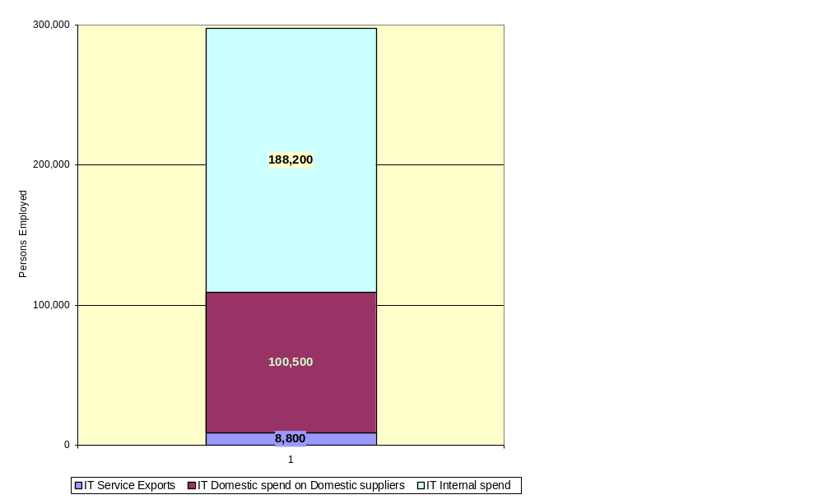
Figure 13
Structure of Australian IT Employment, 2001
Source: Centre for Strategic Economic Studies, Victoria University, Australian ICT Trade Updates, IDC Digital Planet 2002: The Global Information Economy, WITSA, February 2002, Whitehorse Strategic Group own analysis.

6.1.1 Offshoring implications
The current estimate of “offshored” jobs, based on the same analytical approach, is approximately 4,500 in 2001-2. If we accept the Compound growth rates predicated by industry observers, this would grow, over the next few years from a 2003 figure of approximately 7,000 jobs to around 11,000 jobs by 2007-8. Figure 14 below illustrates this more clearly.
Figure 14
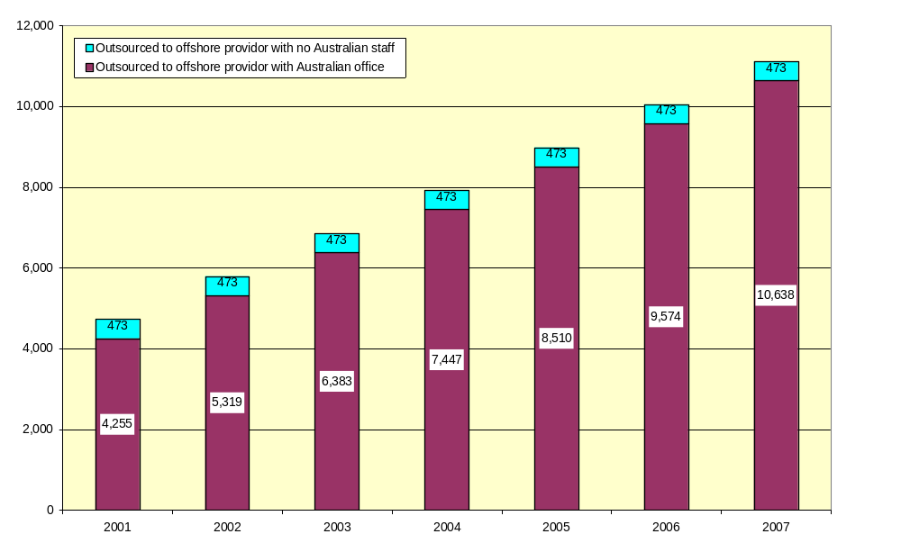
Offshoring jobs growth potential at predicted CAGR
Source: Whitehorse Strategic Group own analysis, Average CAGR prediction of combined Research organisations
However, a recent study by Sweeney Research for Software Engineering Australia which included a telephone sample of 500 respondents, showed a limited current usage of offshore resources by Australian firms. Nearly 75% of the respondents indicated ‘little or no usage’ of offshore resources, and only 10% indicating a ‘very high usage’, refer to Figure 15 below. We therefore consider that the offshore job losses indicated in Figure 14 are probably a “worst-case” scenario.

Figure 15
Proportion of Australian custom software development sourced offshore
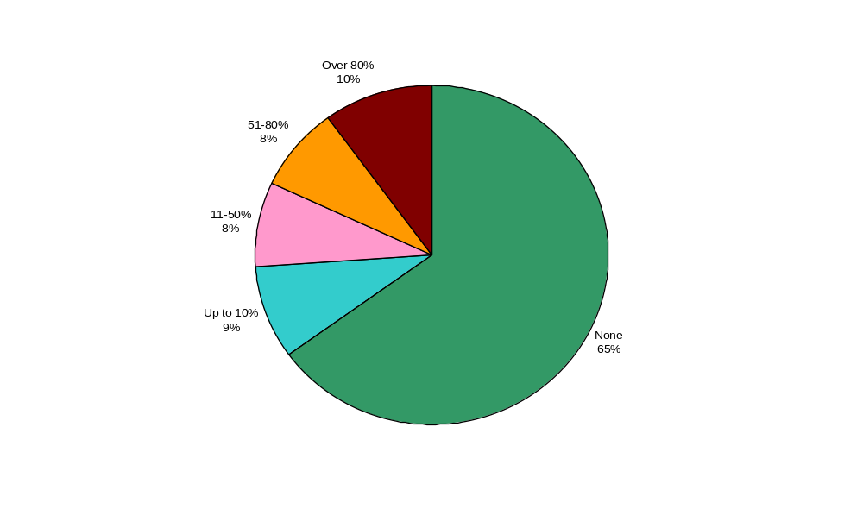
Source: Software Engineering Australia, 2003 Report (Sweeny Research)

Net job losses offshore, however, are mitigated by job growth from “onshoring” (ie. jobs created via IT service exports). This is illustrated below in Figure 16, taking the “worst case” job losses, and current estimates of jobs growth, which develops a minimal net jobs effect.
Figure 16
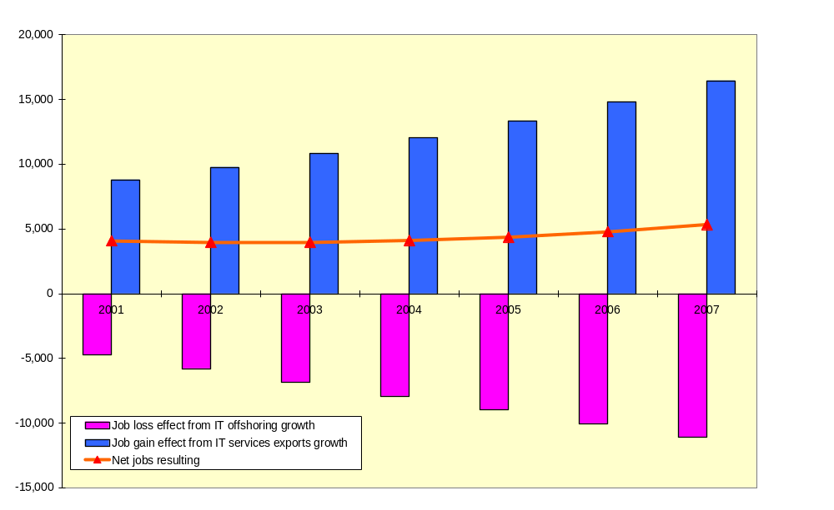
Net Offshoring/Onshoring jobs effect at predicted growth rates
Source: Whitehorse Strategic Group modelling using Centre for Strategic Economic Studies, Victoria University, Australian ICT Trade Updates, IDC Digital Planet 2002: The Global Information Economy, WITSA, February 2002.
It can be argued that while we are allowing jobs growth, gained through improved exports, these are being wasted through offshoring job losses, and that we should therefore be trying to minimise these, in order to maximise overall economic growth.
The net economic gain and leakage impact of the job scenarios presented in Figure 15 are finely balanced, but the main economic cost impact is from repatriated profits to internationally owned outsourcers based in Australia, rather than from direct job offshoring, this was shown earlier in Figure 3 of this Report.

6.2 Economic Impacts
Econsult, in the Ballarat I.T. 2010 report for the Victorian Government and City of Ballarat, analysed differential employment and investment multipliers for metropolitan and regional investment across the IT industry sectors. They ranged from 1.6 to 2.4 type 11a multipliers for job creation (ie. number of jobs in the economy created by one IT job). Metropolitan investment delivered a higher return due predominantly to lower economic leakage (eg. the chance that the job created would be outside the region concerned). It is also noted that the higher levels of job creation are often related to lower rates of wage, that is that the economic value of the jobs created is reasonably similar, however the structure of the jobs may vary sector by sector. In general, investments in software and services generate fewer but better paid jobs, whereas investments in hardware and communications generate more, but lower paid jobs, within the same economic bandwidth.
For every $1 million of investment in the IT industries, Econsult forecast between 22 and 40 jobs created, but considered this forecast approach less reliable than the direct and flow on jobs evaluation.

The Productivity Commission undertook research into the contributions to sectoral labour productivity growth in Australia over the period between 1993-94 and 1999-2000. The study revealed that through ICT makes a big difference to productivity; its effect is spread unevenly across industry sectors. The research found that ICT contributed 1 percentage point towards overall annual labour productivity growth of 3 per cent in the six-year period to 2000.

6.2.1 Impact on tax base
If as projected a potential further 4,000 jobs go offshore over the next 5 years, assuming an average salary of $75,000, this will equate to $300 million in lost wages. Multiply by 1.5 (ABS estimate of IT services output multiplier effect) to account for trickle down economic benefit effect, and lost economic activity equates to $450 million. The potential total tax loss is then estimated at $135 million. However, the loss may be temporary as some of the permanently displaced ICT workers will find new jobs in other industries. There will also be costs incurred by the displacement of ICT workers, such as unemployment insurance, increase in the number of social security recipients, and costs associated with re-skilling those displaced by offshoring.
$450 million potential economic wastage

6.2.2 The outsourcing employment bump
Employment in the ICT industry has fallen since the heady days before the dotcom crash in early 2000, where the industry in Australia was fuelled by the mandatory business requirements of GST and Y2K and growth in internet related work. The focus by many corporates and government since the dotcom crash has been on maintaining IT budgets and trying to improve the productivity of existing ICT investments. This has encouraged CIOs to look at outsourcing options to lower costs. Selected recent examples of outsourcing deals reported in the media are contained in Appendix Two of this report.

The following statement supports the analysis of the employment bump created by the economic cycle "The tech industry evolves through waves lasting 10 to 15 years, as innovation leads to a burst of spending on new technologies, then to a less exciting period of assimilation. Firms have now entered the assimilation phase, with the emphasis on making tangible returns on their technology investments, past and present." Source: The Australian, 7 October 2003, Steven Milunovich "IT still in a cold spell, with spending up and down".

Figure 17 below shows the long term sustained growth in employment in IT companies focussed on IT services. The “bump” in 2000-2001 represents the displacement of a significant numbers of IT professionals from the user community (mostly Government) to the supplier community (outsourcers). At the time, and subsequently, this has been treated as, and claimed as, industry growth. The long-term trend, however, suggests that exactly the same employment in IT services would have eventuated regardless of this process.

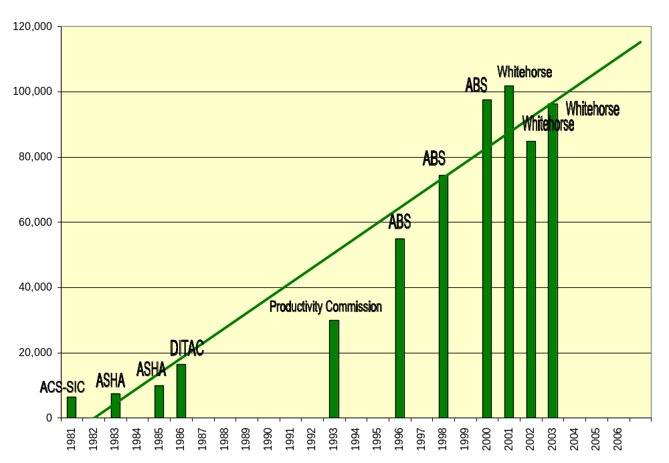
Figure 17
Trend in Software and Consulting Services Sector Employment in Australia
Source: Whitehorse Top 250 Survey and Modelling, unpublished data from Australian Computer Society Software Industry Committee, Australian Software Houses Association, Department of Industry Technology and Commerce, Productivity Commission, and Australian Bureau of Statistics.

7. Likely Outsourcing and Offshoring market trends in Australia

7.1 Market slowdown
Whitehorse consider that the Australian Outsourcing market growth will NOT continue at the high compound annual growth rates (CAGRs) predicted by many industry analysts, and may retract from existing levels over time.
Whitehorse also consider that the offshoring component of Australian IT outsourcing WILL grow for the next two years, but will also then level off from predicted CAGRs.

7.2 Our reasoning
Market growth takes place because of unmet demand; because the product or service is “fashionable”; and because the product or service offers real cost-benefit.

7.2.1 Demand
For Outsourcing in Australia, demand has diminished because of significant market achievement “all the Mega-deals have been done” (EDS spokesperson), causing outsourcers to now target mid-size companies/deals.
In Australia, unlike the US, there are not that many mid-size companies with IT budgets of the size that can justify the overheads of an outsource, rather than simply the purchase by the client of required services from existing, often local suppliers. After all, 90% of all Australian employment is in small business.
The level of competition to provide such services to mid-size and smaller clients will also be broader, since it will then tend to include many other IT service providers, who may be niche specialists, many with lower overhead thresholds than the larger outsourcers.
Since the market potential is now diminished, it is unlikely to grow as quickly.

7.2.2 Fashion
A large amount of currently outsourced IT has derived from Government driven projects, often based upon false assumptions of economies. Whilst these outsources may recycle, the concept that outsourcing is always the solution is no longer fashionable.
The current hype about Business Process Outsourcing (BPO) appears to be a last gasp attempt to expand the perception of a growing IT outsourcing market by including functions that were never part of the IT purview.
‘BPO’ is hype
Since the outsourcing fashion peak has been passed, it must grow on other factors from now on.

7.2.3 Cost-Benefit
There will continue to be effective outsources where there are true economies of scale, or access to scarce technical resource. Cost benefit outside these paradigms can normally only occur where there has been previous inefficiency or feather-bedding.
As a general rule, smaller clients are less likely to exhibit sufficient inefficiencies to offset the sales/admin/marketing/support/overheads/profit costs of an outsource, as these costs for the outsourcer are much the same, whether the outsource is $100 million per year or $10 million.
Since the diminished business is likely to be more competitive and at lower profit margins, vendors will start to develop alternative market scenarios.
Fewer large clients
+ Limited number of smaller clients
+ Few Govt “mandate” clients
= less easy targets
More competition
Outsourcing revenues drop will force new market foci
+ Smaller deals
+ Higher overhead %
= lower profits
Less clients
+ lower profit margins
= find new horizons

7.3 Offshoring implication
Offshoring mirrors all of the outsourcing arguments, except that it mitigates the cost-benefit equation to a limited degree. The optimum model sought by offshoring companies is 80:20, (ie. 80% of the work performed offshore, 20% onshore). Anecdotal evidence suggests that, in Australia, this has rarely been achieved, with more common ratios of 60:40, or even a majority of work performed onshore. Job displacement is also less cost-effective, with the cost for bringing, for example, a SAP expert onshore, is very similar, counting overheads, to the cost of employing someone in Australia.
The 80:20 model doesn’t work in Australia

7.3.1 The likely outcome
Whitehorse consider that the “purist” model (80:20) offshoring company will find it difficult to maintain operational profitability in Australia.
The likely result will be some market exits, by those companies unwilling or unable to adapt, and a gradual change of business model by those remaining, to a pattern of either economically sustainable offshoring for specific cost-effective projects, or components of projects, adoption of a locally based work-force, or hybrid models of the two.

8. Options and Recommendations

8.1 ICT Industry Options
The Australian ICT community has, in our opinion, three clear options in respect to its treatment of offshoring and outsourcing:

- Treat it as an IT “trade” issue, and concentrate purely on the social and employment implications for industry professionals.
- Treat it as a “professional” issue, and concentrate on identifying and improving outsource and offshore decision processes
- Treat it as an economic and political issue, and concentrate on gaining variations in public policy where this is acting against Australia’s interests
Whitehorse suggest that the Australian ICT community take up all three of these options, for the following reasons:
Australian ICT has a key voice in all three options

- It is inappropriate to refrain from comment on “trade” issues where these have what is perceived to be a deleterious affect on industry professionals.
- One of the main conclusions we have drawn is that many outsourcing and offshoring decisions are being made for the wrong reasons, or that the decision processes are professionally flawed. The Australian ICT community can play a major role in promoting the concept that IT decisions should be made by competent and well-trained IT professionals, using appropriate methodologies.
- Government policies, in a number of jurisdictions, have been, and continue to be, a key driver in the trend to outsourcing. Poor initial decisions are now leading to a greater propensity for offshoring, whether directly by the agency concerned, or via Australian based entities trying to achieve anticipated cost reductions. The Australian ICT community can play a leading role in identifying short-sighted IT related policies that act against Australia’s long term interests.
- We consider that it is important to take up a fourth option, that of actively promoting Australia’s capability and attractiveness as an ICT investment location and as a centre for high quality and high value ICT research and software and telecommunications development projects.

8.2 Australia as an Outsourcing destination

Neville Roach (Chairman of the Australia-India Business Council and former head of Fujitsu Australia) identified the following six factors in Australia’s favour as a destination for outsourcing:

- Excellent education system producing a large number of hi-tech specialists.
- Large numbers of students from India and China studying IT in Australia as we have lowest cost education amongst English speaking countries.
- An immigration program to supplement a pool of specialists.
- People with experience in advanced ICT applications.
- World-class infrastructure.
- Better security than most offshore competitors.
Source: The Australian, September 16, 2003, Diana Thorp ‘Offshoring stoush hinges on future entry-level jobs’.

The recent McKinsey Report, prepared in conjunction with the Federal Government “ICT Framework for the Future” project, did highlight two major opportunities for Australia:

- “Globally oriented specialist businesses are likely to play an increasingly important role in the ICT industry in Australia. Business opportunities are likely to be in ‘vertical’ applications (ie. specialised applications in sectors such as mining that have relatively unique needs and a sophisticated customer base); specialist ‘horizontal’ applications (such as security services, which apply widely across industry sectors); the development of consumer applications such as computer games, specialised operating systems for embedded microchip applications; and specialised technical and outsourcing services.

- Opportunities exist to provide specialist functional skills and services in support of multinational corporations. Examples are: undertaking word-class high-end software R&D for multinationals; providing regional hubs for high-end technical support services (eg. virus response), and for high-end professional services (eg. systems design and architecture), support and maintenance, and undertaking specialised hardware R&D (eg. network equipment, and mobile handsets) taking advantage of Australia’s current expertise in this area and it’s sophisticated customer base.”

Whitehorse have also recently completed a Victorian Government study analysing ICT investment and outsourcing decision factors, and a comparison of Australia’s standing in these relative to a number of other potential locations. Australia, on these indices, is highly competitive – even against other significantly lower cost locations.

8.3 Options for Responding to Offshore ICT Outsourcing
Study Conclusions | Recommendations to the Australian ICT community
Variations in public policy towards outsourcing and offshoring
The annual value of Outsourcing, globally and in Australia is overstated, poorly defined, and growth is often exaggerated, U.S. Paradigms often don’t apply in Australia and can create false conclusions. | - Refrain from accepting unsubstantiated press reports, and market extrapolations based upon imported data.
 | - Develop and encourage the use of Australian paradigms and better data.
The Economic loss to Australia from ‘onshore’ outsource far exceeds that from ‘offshore’ outsource. | - Encourage governments to consider and include the ‘economic loss’ equation in decision making processes.
 | - Analyse and present economic arguments for consideration during outsourcing evaluations. Analyse and present economic arguments for minimising offshoring.
 | - Consider the reintroduction of compulsory consideration of insourcing – as an option, for Government agencies
Some offshore is a result of non-achievement in onshore outsourcing deals leading to a search for lowest cost solutions (PANACEA Outsource) | - Publicise “panacea outsource”.
 | - Promote more effective and rigorous outsourcing decision making.
 | - Identify politically driven outsourcing.

Study Conclusions | Recommendations to the Australian ICT community
Identifying and improving outsource and offshore decision processes
Offshore wages growth and the hidden costs of offshoring are quickly eroding current cost advantages. | - Promote the use of ‘whole of life’ costing .
 | - Publicise the diminishing cost equations.
Offshore productivity may, in many cases, be considerably less than inshore productivity | - Identify software productivity differences.
 | - Commission a ‘software productivity study’ to reinforce the local Australian advantage in comparison to other locations.
Some offshore is a result of non-achievement in onshore outsourcing deals leading to a search for lowest cost solutions (PANACEA Outsource) | - Develop and present training in outsource decision making
Study Conclusions | Recommendations to the Australian ICT community
Social and employment implications for ICT professionals
Australian Outsourcing market growth will NOT continue at the high compound annual growth rates (CAGR’s) predicted by many industry analysts, and may retract from existing levels over time.  The offshoring component of Australian IT outsourcing WILL grow for the next two years, but will also then level off from predicted CAGR’s. | - Measure the Outsource/Offshore market for a further two years and monitor growth
The current employment loss to offshore, whilst serious, is not terminal | - Reassure ICT professionals
The compensatory employment derived from IT Service exports, offsets employment losses from offshoring. | - Measure IT Service Exports for a further two years and monitor growth.
Some IT professionals need re-skilling | - Establish specific re-skill programs for IT professionals
Australian supply of new ICT professionals is not growing rapidly. | - Market and reinforce ICT as a long-term career
Job transition may be difficult for older employees | - Suggest to Government a greater focus on easing job transitions for white-collar workers by making pensions and insurance more portable across jobs, and offering tax credits for older employees who want to relocate to find a new job or go back to college for retraining.

Study Conclusions | Recommendations to the Australian ICT community
Promoting Australia’s capability and attractiveness
Growth in IT Service exports may be able to compensate for growth in IT service imports | - Encourage IT Service exporting. Promote Australia as an ‘inshoring’ destination for the American, European and Japanese markets.
Australian ICT industry has an increasing Asia-Pacific ownership and focus | - Encourage Asia-Pacific linkages and exchanges, develop specific Asia-Pacific focussed events
 | - Encourage “newcomer” companies to engage with Australia, eg. signing memorandum of understandings with Australian Universities to share technology research, which will lead to recruitment and job creation in Australia.
 | - Identify international project opportunities for Australian IT professionals, especially in South-east Asia.

Appendix One – Analyst Comments on the Global ICT Outsourcing Market
Aberdeen Group:
“The Aberdeen Group estimates that offshore outsourcing represents about 2% of the $400 billion market for global IT services”.
Source: Information Week Sept 2, 2002 Diane Rezendes Khirallah ‘More than ever, world events affect offshore outsourcing choices’.
Accenture:
“Plans to double its Indian workforce over the next six months to November 2003. Accenture had 2,200 Indian employees in May 2033 and plans to surpass 4,000 by November 2003. The work is primarily back-office in nature”.
Source: www.Top–consultant.com newsletter September 17, 2003

“Andrew Friars Accenture Asia/Pacific Managing Director of BPO reports that Australia spent US$2.4billion (A$3.5b) on IT outsourcing in 2002. The use of offshore centres by Australian clients is growing rapidly, but Australia hasn’t taken this opportunity up as much as the rest of the world for a very good reason: labour differentials between Australia and these centres are not as great as other locations so the value proposition is not as great”.
Source: Corporate Outsourcing journal September/October 2003 “Over to you Vendors to carry the risk in 2004”
AMR Research:
“AMR Research expects that the number of companies outsourcing applications management to offshore service providers to grow within 12 months by 50%, with 35% of all users to outsource some piece of IT to offshore resources. Today the number of offshore IT jobs account for less than 3% of the US total”.
Source: The Rust Report, May 23, 2003 ‘Users to outsource IT offshore’.

AT Kearney:
“Expects US jobs worth $150 billion to move offshore by 2015”.
Source: www.top-consultant.com newsletter, September 10, 2003.
Bradstreet:
“Bradstreet report estimates that the global market for IT related outsourced services will exceed $200 billion in 2003”.
Gulf News Sept 6, 2003 Henry Azzam ‘Vantage View: Region needs to tap trend of outsourcing services’.

Butler Group:
“Worldwide market for outsourced services will grow from US$75 billion in 2001 to reach US$175 billion in 2005. Over 50% of FTSE-1000 companies adopt offshoring for at least some of their application development work. India has over 50% of the off-shoring market. The worldwide off-shoring market will grow from US$17 billion in 2001 to US$50 billion by 2005”
Source: Butler Group ‘Strategic Sourcing Report’, October 2001.

“The target for the export of Indian software in 2001 was US$50 billion per annum by 2008. In 2000 turnover was just over US$6 billion with 60% from the United States. In 2001 India accounted for 75% of all off-shoring deals, but only 50% of revenue. In Europe Butler Group believes that offshoring revenue will reach almost US$14 billion in 2005”.
Source: Butler Group Report ‘Off-Shoring – What is involved?’ by Maxine Holt, September 2001.

ConnectitChina:
“ConnectitChina a Shanghai consultancy estimates China’s software outsourcing revenue will more than double to US$5 billion by 2005”.
Source: Bruce Einhorn ‘China is rising fast as a services outsourcing hub’, 2003

CSC:
“Plans to build two new offshore development centres in India in addition to its three existing centres. CSC currently has 700 staff and expect that number to double over each of the next two years”.
Source: www.Top–consultant.com newsletter September 17, 2003

Cutting Edge Information:
“Outsourcing market has slowed since 2000 and is set to grow to 19% annually from 2003 to 2005. Worldwide outsourcing has hit more than US$350 billion in 2002. More than 90% of US companies outsource at least one activity”.
Source Cutting Edge Information - Chip Pecora ‘Outsourcing From Strength’, November 2002.

Deloitte Consulting:
“Deloitte Consulting's Carl Steidtmann argues that U.S. companies that ship IT work to India and other emerging countries will be more competitive, grow faster, and have more money to invest in research and development. All of this, Steidtmann says, will ultimately lead to more, higher-paying jobs in the United States. "Restrictive employment laws in Europe go a long way towards explaining why Europe consistently runs a higher rate of unemployment when contrasted with the U.S. or Britain," Steidtmann says.

Steidtmann also maintains that because, historically, work that has been exported has typically been replaced by higher-level economic activity in another sector, the same will hold true for IT. "How much better off would the U.S. be today if we had saved all those farm jobs a century ago?," he asks. "Just imagine what the economy would look like today if 70% of all American workers were still tilling the soil."
Steidtmann further argues that legislative constraints on outsourcing could lead to protectionism that will do more harm than good to the U.S. economy. "The more the U.S. does to limit the importation of services, the more difficult if will become to export them, which in turn will destroy jobs," says Steidtmann, noting that the country runs a large services surplus with the rest of the world”.
Source: Information Week Paul McDougall ‘Economist: Offshore IT Outsourcing Should Boost U.S. Economy’ Aug. 29, 2003

DiamondCluster International:
“78% of executives who have outsourced an IT function have had to terminate that agreement early”.
Source: CIO April 2003, ‘Bring IT Back Home’ DiamondCluster International Nov 2002 study.

Evans Data:
“Evans Data Enterprise Development Management Issues Survey conducted in May 2003, found that 65% of large enterprises outsource some of their development, up from a low of 40% in early 2001. 13% of that outsourcing goes offshore, more than double the amount from 2002. Amongst larger companies (20,000 or more employees) 75% outsourced some projects and 22% outsourced more than 25% of their projects. Amongst companies with IT budgets of more than $US10 million 85% outsourced some projects and 65% outsourced more than 25% of their projects and 7% outsourced more than 75% of their projects”.
Source: The Rust Report, August 29, 2003 ‘Software outsourcing gains steam’.

Forrester Research:
“Forrester Report the BPO market will continue to grow, reaching $146 billion by 2008”.
Source: www.top-consultant.com

“Firms spend an average of 12% of their IT budget on offshore outsourcing and this is predicted to grow to over 28% by 2004. 2 out of 5 fortune 500 firms currently outsource some software requirements to India”.
Source: Forrester Research, 2002.

“Almost 560,000 tech jobs were lost from 2001 to end of 2002 according to American Electronics Association. Forrester Research Nov 2002 report by John McCarthy estimated 3.3 million US jobs (472,632 in IT and mathematics) and $136 billion in wages will go overseas by 2015”.
Source: The Times-Picayune, Sept 7, 2003 ‘As tech goes south, jobs go overseas’.

“Forrester estimates that the number of US computer jobs (including professionals) moving offshore will grow from around 27,000 in 2000 to a cumulative total of 472,000 by 2015. If the Forrester scenario in the US also broadly applied to Australia that could mean a loss of nearly 40,000 computer jobs in Australia by 2015”.
Source: The Australian newspaper, August 19, 2003. ‘Offshoring to cost 40,000 jobs’.

Gartner:

Gartner analysed 1,055 IT outsourcing contracts from 2003 dating back to 1989. This covered contracts with more than 190 IT outsourcing vendors and 14 industries across the globe. The study revealed the following statistics:
- “Average value of an IT outsourcing contract is US$47 million.
- Average contract duration is six years.
- Half (54%) of all contracts are worth less than US$100m.
- Megadeals (defined as those worth US$1 billion or more) account for 9% of all IT outsourced contracts, but represent two-thirds of the total value of all contracts.
- Financial services and government have the most billion-dollar megadeals at 17 each, with high-tech industries accounting for seven of those big deals.
- Aerospace and defence industries have the most valuable annual contracts among vertical industries, with an average annual value of more than US$88 million, followed by the automotive industry (US$87.4 million), and high-tech (US$80.5 million)”.
Source: CIO magazine, May 6, 2003 Ed Parry Gartner averages values of IT outsourcing contracts.

“In 2002 Western Europe businesses wasted more than US$9.5b on bad outsourcing deals. Gartner said the investments became money pits because companies signed deals to save money in the short term and didn't pay enough attention to the long term and had trouble coping with change. Expensive reviews, re-done deals and abandoned contracts were the most draining aspects of those deals”.
Source: CIO, 6 may 2003, Ed Parry ‘Gartner averages values of IT outsourcing contracts’ .

“Gartner claims that Indian software developers secured just AU$71.71 million (2%) of the Australian sourcing market for development and integration services, out of a total market size of AU$3.585 billion. Five Indian companies: Tata Consulting services, Satyam, Infosys technologies, Pentasoft and three companies in the HCL group, grew by 36% in 2002/03. The top 10 players in Australian software development and integration sector accounted for 46% (i.e. AU$1.649 billion)”. Source: ZDNet Australia, 28 July 2003 ‘Australia overreacts to Indian outsourcing: Gartner’

“Gartner Survey indicates that 58% of Australian companies outsource at least one of their IT operational functions”.
Source: Computerworld newspaper August 18, 2003 ‘Analysis: Outsourcing reloaded’ by Craig Baty, Gartner Research.

“Gartner predicts market for BPO done offshore will hit US$1.8 billion in 2003, up from US$1.3 billion in 2002, but still the offshore BPO market will make up just 1.5% of the total BPO market in 2003. More than one-third of companies with 1000 or more employees obtain offshore BPO services from US based BPO providers. India’s revenue from Business Process Outsourcing (BPO) will grow from slightly under US$1 billion in 2002 to US$1.2 billion in 2003 and will represent 66% of the offshore BPO market”.
Source: ZDNet Australia 10 July 2003, ‘Overseas outsourcing to rise in 2003’.

“Up to 10 % of IT professionals in the US to lose their jobs by 2004 because of offshore outsourcing”.
Source: ZDNet Australia 24 July 2003, ‘Offshore outsourcing anger will ebb in 2004: Gartner’.

“Since 2001 more than 500,000 IT jobs lost according to US Bureau of Labor Statistics. Gartner analysis indicates that 500,000 more IT jobs could disappear by the end of 2004 from a workforce of 10.3 million IT practitioners. By the end of 2004 one in every 10 jobs within US based IT vendors and IT service providers will move to emerging overseas markets, as will one in every 20 jobs in non-IT companies. Through 2005 fewer than 40% of people whose jobs are moved to emerging markets will be re-deployed by their current employers”.
Source: CIO August 13, 2003 ‘U.S. Offshore Outsourcing Leads to Structural Changes and Big Impact’, U.S. Offshore Outsourcing: structural Changes, Big Impact by Diane Morello, Garner Inc, 15 July 2003.

“Diana Morello from Gartner predicts that 5% of technology jobs are at stake for offshoring in the wider corporate world in 2003-04”.
Source: E-Business Strategies, 2003, ‘Offshoring statistics – Dollar Size, Job Losses, and Market Potential’.

“India dominates 80-90% of total offshore development revenue worldwide”.
Source: Gartner, 2002.

“Outsourcing deals in India in 2002 were worth US$10 billion, 85% of entire offshore outsourcing market”.
Source: Computer world newspaper July 21, 2003 Ian Marriott Gartner Analyst ‘Russia lines up as offshore outsource centre’.

“Gartner predicts that by 2007 China will pull in US$27 billion for IT services including call centres and back-office work, to match India”.
Source: Bruce Einhorn ‘China is rising fast as a services outsourcing hub’, 2003.

“According to Gartner, spending on offshore outsourcing in the USA will rise from $6.6 in 2002 billion to $15 billion in 2007. That's quite a rise. There is likely to be a similar rise in Europe - but from a lower base. Currently, according to the latest statistics, only 8% of UK companies are currently offshore outsourcing”.

“Gartner Dataquest forecasts that the US$536 billion worldwide IT services industry in 2002 will grow through 2007 to reach US$707 billion, with a compound annual growth rate of 5.7% with services for process management and IT management to be the hottest growth areas”.
Source: Gartner Worldwide IT Services market Forecast 2002-2007 Report 7 August 2003.

“Nearly 20 percent of companies that farmed out IT work did not achieve any cost reductions, while 9.2 percent experienced an increase in costs, according to a survey by Gartner company people3”.
Source: ZDNet 18 November 2003, Ed Frauenheim “Outsourcing not always a money saver.
GlobalOutsourcing:
“IT-related outsourcing representing approximately 40% of the US$214b global outsourcing market in 2002, is expected to grow at about 18%”.
Source: www.GlobalOutsourcing.org ‘Outsourcing: Advantage India, October 2002.

IDC:
“42% of all active outsourcing software application management contracts have an offshore component - TPI Inc and IDC global survey”.
Source: Computerworld June 30 2003, Juan Carlos Perez. Offshore outsourcing pushes down services prices.

“Global IT outsourcing market has grown from US$96 billion in 1998 to US$151 billion in 2000”.
Source: IDC, 2000

“IT outsourcing reached US$56 billion in 2000 and is expected to top US$100 billion by 2005”.
Source: IDC, 2001 ‘IT Outsourcing: The State of the Art’

“IDC estimates that the next big wave will focus on outsourcing of business processes of finance, hr or other parts of business. Market worth US$712b in 2001 and grow to US$1.2trillion by 2006”.
Source: Australian Financial Review Emma Connors May 5, 2003 ‘Protests fail to stem outsourcing’.

“Worldwide outsourcing spending will increase from US$116b in 1999 to US$177b by 2004 at CAGR of 8.8%. US to account for 50% of spending worldwide, with US outsourcing spending increasing from US$56b in 1999 to US$87b in 2004”.
Source: www.GlobalOutsourcing.org February 2003, Outsourcing: The Great IT Rush’.

“Worldwide spending on information systems outsourcing services reached more than $68 billion in 2002 and is expected to surpass $99 billion by 2007, representing a five year CAGR of 7.7%. In 2002 the United States accounted for 45% of the worldwide IS outsourcing spending. Countries in Asia/Pacific spent the least on IS outsourcing services, but will experience the highest spending growth through 2007, with a CAGR of 9.2%”.
Source: IDC report, Worldwide and U.S. IS Outsourcing Services Forecast, 2002-2007, April 2003.

“IDC predicts India’s call centre market will clock over 50% CAGR until 2005, ahead of China’s 40% plus CAGR. The total size of the call centre services market in Asia Pacific will grow to over US$4b by 2005 from US$1.2b in 2000. The $480m Australian market in 2000 would grow to US$924m in 2005, at a 14% CAGR”. Source: IDC Press Release, 16 March 2001 ‘IDC Says Call Centres Set for Rapid Growth in Asia/Pacific Region’.

Input:
“Market research firm Input says that the total market — encompassing traditional IT outsourcing, business process outsourcing (BPO), and processing services — will grow at a 19 percent annual clip until 2005, eventually topping $260 billion”.
Source: AriaSys Jan 28, 2002 ‘Outsourcing Special Report’
McKinsey:
“Leading global vendors are building offshore presence. Over 70 per cent of the top 30 global IT services vendors have an Indian presence and are now looking at BPO. According to McKinsey, the labour factor cost savings itself would be about 30 - 40 per cent. Capital productivity could be a huge differentiator among providers. Says Noshir Kaka, Principal, McKinsey, "Even at a commoditised rate, vendors can make 30 per cent margin with capital efficiencies". According to McKinsey, four models of ITES and BPO have emerged - onshore outsourcing, offshore outsourcing, shared services, and captive offshoring. Offshore outsourcing or ITES-BPO from the Indian perspective is the model that is expected to have the largest potential”.
Source: Cyber nation India, February 12, 2003 ‘McKinsey says offshore outsourcing to boom’

Merrill Lynch:
- “Accenture has 2000 people in India and add 500 more by January 2004.
- Computer Services Corp, 1000 people in India and add 1000 more by July 2004.
- IBM Global services 4,500 people now in India and add 1500 more by March 2004.
- Cognizant 4500 people now in India and add 1500 by January 2004.
- Science Applications Intention to establish software development centre in India by Sept 2003.
- Infosys Technologies and Wipro revenue to exceed A$1.5billion in calendar 2003”.
Source: Data from report by DSP Merrill Lynch - The Australian newspaper ‘More US software jobs going to India’, 19 August 2003

Meta Group:
“Meta Group predicts that offshore outsourcing will grow by more than 20% annually, pushing it from a US$7billion market in 2003 to a US$10 billion market by 2005, and US$15billion by 2007”.
Source: E-Business Strategies, 2003, ‘Offshoring statistics – Dollar Size, Job Losses, and Market Potential’.

“Research from META Group indicates that 70 per cent of Australian companies are renewing outsourcing contracts but with reduced scope and shorter duration. META Group also predict that as mega-deals fade away, the Australian outsourcing market will shrink by an estimated 30 percent by 2004”.
Source: Corporate Outsourcing journal September/October 2003 “Over to you Vendors to carry the risk in 2004”
NASSCOM:
“India produces 73,500 software professionals annually. The global software market is currently estimated to be around US$150 billion, almost 30 times more than the revenues earned by Indian software industry and growing fast. R&D spending by the Indian software industry was a measly 3.4% of revenues earned during 1999-2000”.
Source: National Association of Software and Services Firms (NASSCOM) Report (2002) ‘The IT industry in India: Strategic Review 2002’.

“Indian IT software and services industry grossed annual revenue of US$5.7 billion during 1999-2000”.
Source: NASSCOM BCG Report (2001) ‘E-Commerce Opportunities for India Inc’.

“NASSCOM estimates that U.S. companies will save up to $11 billion in 2004 by outsourcing to India and that India will purchase $3 billion in high-tech imports from the United States in that time”.
Source: Sunil Mehta vice president of the National Association of Software and Service Companies (Nasscom), CIO magazine, September 2003, Christopher Koch, ‘Backlash’

Neo-IT:

“As more jobs move offshore, the work will move higher on the IT food chain. Indeed, it already has. The CIO survey found that 11 percent of the companies had outsourced system and architecture planning offshore, and 14 percent had outsourced research and development—two categories that analysts and chief information officers have predicted would never leave these shores. "When people say there is IT work that can't be done offshore, I disagree; it just takes longer to move the more complex work offshore - Atul Vashistha, CEO of Neo-IT "
Source: CIO Magazine, September 2003, Christopher Koch, ‘Backlash’.

“Neo-IT outsourcing company says global software exports were worth US$300b in 2002 and India shared 2% of that market worth US$6b and is expected to grow to $40b by 2004”.
Source: www.GlobalOutsourcing.org ‘Outsourcing: Advantage India, October 2002.

Ovum:
“Ovum forecasts that the offshore sector revenues generated in the UK will reach 1b pounds by 2006 and the total for Europe will hit 2b pounds by 2006. Ovum also forecasts that 25,000 jobs may be lost in the UK IT industry over the next few years as a direct result of IT work moving offshore. In the past offshore players offered business savings of 40% but as a result of price reductions in 2002 and 2003 this has is now typically in the 20-25% range, which still remains as a substantial saving. The three Indian offshore specialists TCS, Infosys and Wipro hold 90% of the world’s offshore market. The Indian government assists them with tax breaks and by priming graduates for the IT sector. Ovum does not anticipate that any country will produce a group of indigenous offshore companies to rival that of India before the end of this decade”.
Source: OvumHolway Phil Codling Offshore Services Report 2003.

Pierre Audion:

“Romanian market for offshore IT services increased 43% in 2002 compared to 2001. There are 4,500 ICT professionals graduating each year in Romania. There are more than 7,700 Romanians working in web and call centres”.
Source: Computerworld September 22, 2003 Pierre Audoin Consultants Offshore Romania 2003 – Analysis of the Offshore Industry for Software Development and IT services in Romania.

TPI:

“TPI predicts that the number of megadeals will most likely decrease in 2003. David Garrity analyst from American Technology Research indicates that in most outsourcing deals, service providers face capital expense costs in equipment and connectivity charges of 5-10% of the face value of the contract. Overall megadeals are less profitable for the service providers compared to smaller deals because of stiff competition in bidding”.
Source: zdnet Australia September 4, 2003 Ed Frauenheim ‘Services megadeals not quite so mega’.

Appendix Two – Australian ICT Outsourcing Market Selected Examples

The following are selected examples of organisations in Australia recently involved in outsourcing or backsourcing work:

“Qantas signed a 10 year contract with Oracle to roll out in October 2003 its $200million e-business program based on Oracle’s E-business Suite. Qantas hopes the outsourcing arrangement will save as much as $35 million. Oracle will provide outsourced management services for the software which will be hosted at an IBM Global Services facility in Sydney”.
Source: The Australian newspaper Sept 16, 2003, James Riley ‘Qantas win lifts Oracle’.

“Qantas plan to cut a third of its 1,000 IT staff. 230 staff in Sydney data centre affected as Qantas may outsource work to Telstra and IBM GSA. Qantas said it was committed to retaining the 230 employees with those affected not offered employment with the outsourcing provider to be redeployed”.
Source: Computerworld newspaper August 26, 2003, ‘IT staff hit hard in Qantas restructure’.

“ANZ employs 400 staff in Bangalore out of 2200 IT staff internationally. Bangalore does about 35% of the banks IT development work”.
Source: “Aussie-Indian mix pays off” – The Australian newspaper September 2, 2003

“Suncorp bring GIO’s IT operations back in-house following acquisition of AMP in 2002. Created 80 jobs. One of the biggest IT backsourcing projects in Australian corporate history”.
Source: CIO April 2003, ‘Inside Moves’.

“At least 80 HP staff retrenched in Sydney and Melbourne” as result of HP moving call centre operations to its Digital GlobalSoft company in India”.
Source: The Australian newspaper Sept 2, 2003 ‘More HP jobs will be lost to India’.

“Tata Consultancy Services (TCS) established a Global Development Centre in Melbourne. The new Centre will employ 200 ICT professionals”.
Source: Multimedia Victoria, Connecting Victoria newsletter March 2002, ‘Indian ICT Giant Comes to Melbourne’.

“Infosys will set up 250 person Melbourne office by November 2003 to cater for work on the 5 year $75 million contract for Telstra”.
Source: ZDNet Australia 10 September 2003, ‘Telstra Contractor to hire Australians’.

“Infosys secured $10m contracts for consulting on Telstra’s Siebel based ERP systems over Deloitte Consulting and $75m contract for infrastructure services over IBM GSA. Combined IT job losses for both projects is expected to be more than 350”.
Source: Computerworld 22 September 2003, Julian Bajkowski ‘Analysts query Telstra’s moves, jobs plan’.

“Australian CIOs were reluctant to use offshore outsourcing. Satyam is doing 85 to 90 per cent of its Australian business through local development centres. Satyam usually charges A$60-$100 an hour for labour, as opposed to A$100-$150 charged by US-based outsourcers” said Harsh Vardhan, Satyam’s Marketing and Alliances General Manager.
Source: The Australian, 4 November 2003, Simon Haynes ‘Mr. Unpopular closing in’.
“UK firm Anite International will fill 100 jobs in Victoria by mid-2004 to do the work on a major $30 million contract for the Victorian Office of Housing. This was the largest Victorian contract awarded in 2002”.
Source: ZDNet Australia 19 August 2003. ‘UK company pledges 100 new ICT jobs for Victoria’.

“In June 2002 Optus signed a new $500 million contract for outsourcing services with IBM Global Services Australia, extending the IT contract it has had with IBM GSA since 1992, for another 10 years”.
Source: CIO magazine Dec2002/Jan 2003 Sue Bushell - ‘Higher Energy’

“By the end of 2003 UBS will set up a new global support centre in Sydney to deliver technical support services to all 16,000 UBS staff outside of Switzerland 24 hours a day 7 days a week. This will create 200 jobs. Sydney was selected over sites that included India, Singapore, US and Europe”.
Source: Financial Review September 23, 2003 Mandy Bryan Sydney HQ for UBS.

“Western Australia government plans to share IT services to cut $50 million from its $300 million IT budget. Queensland spends $544 million annually on IT and do not see any need for whole of government outsourcing for the moment. South Australia announced it will not continue with its nine year big-bang outsourcing contract with EDS once it ends in 2005. NSW kept IT work in-house and recently increased Argus Telecommunications the government telecoms unit. Victoria is looking for a whole of government telecommunications purchasing project to start in 2004 worth $2 billion over 10 years”.
Source: The Australian September 16, 2003, Simon Hayes ‘Governments slash tech’.

“In October 2003 the Department of Defence issued a tender for contracting out centralised IT infrastructure support for its 90,000 registered users. The contract will commence in early 2005. The total ISD budget is $500m and the contract is expected to be 15% of that ($75m)”.
Source: Financial Review September 23, 2003, Ben Woodhead Defence looks at outside computer help’

“DCITA recently signed outsourcing contracts with KAZ Group ($4m) and Macquarie Corporate Telecommunications ($800K), and Volante also won $9.4m contract with the Electoral commission. The Group 5 Cluster Agreements end in July 2004. Australian owned tier 2 outsourcing venders have previously argued that the deals were too large for them to be competitive. If EDS lose the Whole of South Australian government contract when it expires in 2005 this could mean the loss of 500 local jobs from the 2,000 strong EDS workforce in the state. Department of Veterans Affairs IT outsourcing contract with IBM cost $65 million when it was signed in February 1997, but the Departments total expenditure on the project was expected to be at least $140 million when in ended in November 2002. The case for outsourcing originally promised savings of $20million over the five years”.
Source: The Australian newspaper ‘Federal outsourcing cost double’.

“The Australian National Audit Office (ANAO) has reappointed Unisys as its outsourcing provider with a new contract worth $4.8 million over four years”.
Source: Computerworld, October 6, 2003 ‘Unisys outsourcing win’.

“Australian Taxation Office spending with outsourcing giant EDS is expected to surpass $1.33 billion by mid 2006, half a billion dollars more than the $800 million face value of two outsourcing contracts signed with the company over the past five years”.
Source: The Financial Review 24 November, 2003 Ben Woodhead ‘$500m overrun for ATO outsourcing’

“Major universities are starting to quietly shift helpdesk work overseas as part of a follow the sun support strategy. Macquarie University has signed up with the London School of Economics and the University of Colorado to swap support services. The Council of Australian University Directors of IT (CAUDIT) wants to expand the initiative to other English speaking institutions”.
Source: The Australian Sept 16, 2003 Simon Hayes ‘Global uni helpdesk follows the sun’

References
Access Economics, The Impact of Sponsored Temporary Business residents on Australia's Living Standards, Prepared for the Department of Immigration and Multicultural and Indigenous Affairs, May 2002. http://www.immi.gov.au/research/publications/temp_res_livingstandards.pdf
Australian Computer Society, Annual Remuneration Survey Reports
Australian Computer Society, 1997 White Paper Outsourcing and contracting out of IT products and services
Australian Computer Society, New Study reveals ICT unemployment nearly twice National Average, Media Release, 20 February 2003
Australian Computer Society, Skills Assessment (For Migration Purposes Only), Procedures Information Manual, PIM 2 Issue 4, 1 October 2003.
Australian Computer Society, Urges Caution on Whole of Government IT Outsourcing, Media Release, 11 May 1997 http://www.acs.org.au/news/outsourc.htm
Australian Bureau of Statistics, Information Technology Australia 2000-01, Catalogue no. 8143.0
Australian Bureau of Statistics, Labour Force Surveys, Catalogue no. 6203.0, Unpublished data
Australian Bureau of Statistics, Population Census, 1996 and 2001
Australian Information Industry Association, Survey of Salaries and Remuneration Packaging in the Australian ICT Industry
Australian Financial Review, 21 January 2004, Rachel Lebihan, “IT courses struggle to attract students”
Bombay Stock Exchange, Timeseries of BSE-TECk index 2000-2003
Budde Communications, Australia Industry Outsourcing Report, September 2003
Butler Group, Strategic Sourcing Report, October 2001
Centre for Strategic Economic Studies, Victoria University, Australian ICT Trade Updates
CIO magazine, September 2003 – Stephanie Overby, The Hidden Costs of Offshore Outsourcing
CIO Magazine, September 2003 - Chris Koch, The Visa War
Computerworld, 4 November 2003, Vodafone sheds 100 staff under outsourcing program
Delegation of the European Commission to Australia and New Zealand, September 2003 Background Newsletter
Department of Communications, Information Technology and the Arts, Enabling Our Future - ICT Framework for the Future, 15 April 2003
Department of Education, Science and Technology, Selected Higher Education Statistics
Department of Employment and Workplace Relations, ICT Vacancy Index
Department of Employment and Workplace Relations, ICT Skills Shortage Survey, October 2003
Department of Employment and Workplace Relations, IT Graduates – Employment Outcomes and Starting Salaries 2003, unpublished data.
Gartner. Press Release April 2003
Graduate Careers Council of Australia, Gradstats, 1999-2003, www.gradlink.edu.au
Hays Salary and Recruitment Survey 2001.
IDC, Digital Planet 2002: The Global Information Economy, WITSA, February 2002
IDC, Report 2002, Australian IS Outsourcing Forecast and Analysis 2001-2006

Janco Associates, September 2003, CIA World Factbook.
Lane S. Aberdeen IT services Practice, Aberdeen Group, November 2001, Offshore software development: Localization, globalisation and best practices in the evolving industry
McKinsey, Australia: Winning in the Global ICT Industry, 2003
National Association of Software and Services Companies, India, Manpower Resources Survey 2001-02
National Association of Software and Services Companies, India, Press release July 17 2003, ‘NASSCOM announces Top 20 IT Software and Service Exporters in India’
Organisation for Economic Co-operation and Development, eBusiness and ICT Skills in Europe, June 2002
Pierre Audoin Consultants, www.pac-online.com
Productivity Commission, Uptake and impacts of ICTs in the Australian economy, December 2002
Software Engineering Australia (S|E|A|), What’s Bugging Australia’s Software Industry? 2003 Report
Sydney Morning Herald, Stan Beer, New test for foreigners, November 25 2003.
The Australian, October 7, 2003 Diana Thorp “Kanbay seeks to tap local talent”

The Australian, 7 October 2003, Steven Milunovich "IT still in a cold spell, with spending up and down"
The Economic Times of India, 5 December 2003, “Australia to relax student visa norms”
US Department for Professional Employees, AFL-CIO, Michael W. Gildea, testimony before the House International Relations Committee on the L-1 Visa Program, February 4, 2004. http://wwwc.house.gov/international_relations/108/gil020404.htm
US Department of Commerce, Digital Economy 2002 Table 6.2 US Trade in IT services
US General Accounting Office, H-1B Foreign Workers: Better Tracking Needed to Help Determine H-1B Program’s Effects on US Workforce, September 2003.
US Stock Exchange, Timeseries index of NASDAQ 2000-2003
The Outsourcing Institute, US, 2003
Whitehorse Strategic Group, The Whitehorse Top 250 Report, Information Technology and Telecommunications Industry Survey, August 2003
Whitehorse Strategic Group, Out-Right Outsourcing Methodology, 1995
Yoshimura Kenichi, MRTA 1259, 3 March 2003, [2003] MRTA 1259
Note: Other References are cited in Appendices One and Two.

